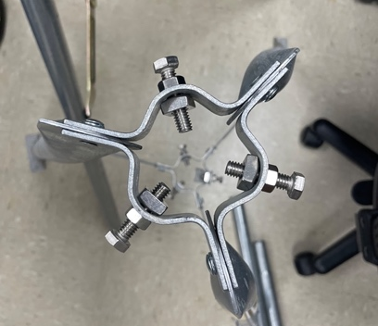
Hardware Assembly Instructions:
- Take everything out of boxes
  - Remove and categorize all parts needed for assembly, in the same step, check for any instruction manuals that may come with the individual parts
Figure 1: Top of tripod
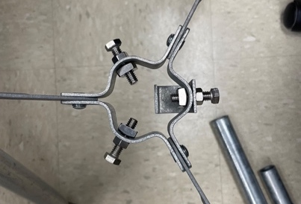
- Assemble tripod
  - See Figure 1 and Figure 2
- Screw data logger into the enclosure
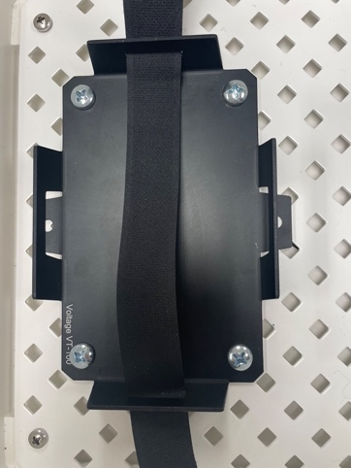
  - Place plastic grommets into holes in the correct spot
Figure 2: Bottom of tripod
  - Attach with screws
- Screw battery holder into enclosure
  - Place screw through battery holder and white backing of enclosure
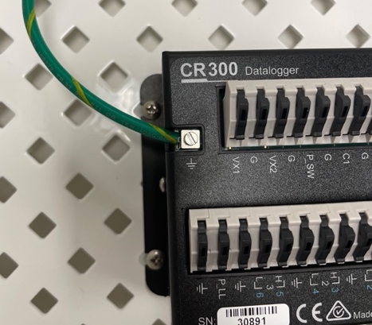
  - Secure with bolt on the back of the white backing of enclosure
Figure 3: Battery holder attached to enclosure
  - See Figure 3
- Connect the data logger to the green cord from the enclosure
  - Unscrew the small screw
  - Strip off the end of the green wire
Figure 4: Wire attached to datalogger
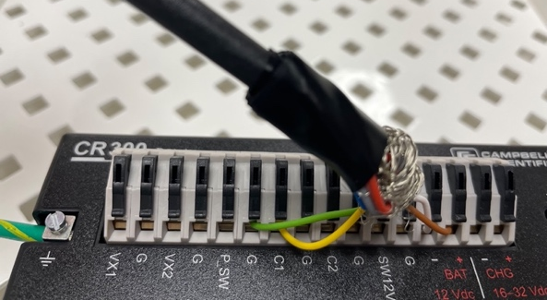
  - Place wire into hole of data logger
  - Rescrew screw into the hole
  - See Figure 4
- Connect wire from lufft to datalogger
  - Place each wire from lufft into the correct place in the datalogger
Figure 5: Close up of wires
  - Green = G
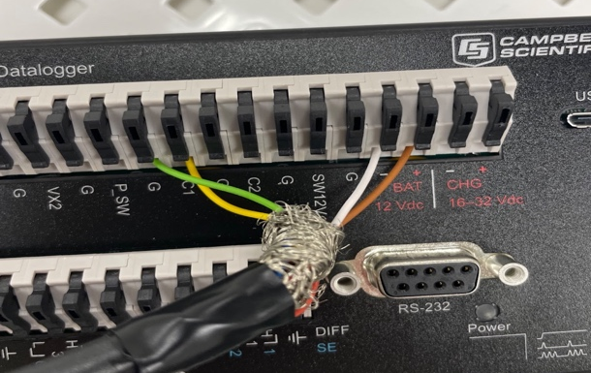
  - Yellow = C1
  - White = -
  - Brown = red +
  - Tape up the rest of the colored wires with electrical tape
  - See Figure 5 and Figure 6
- Connect battery to data logger
Figure 6: Close up of wires
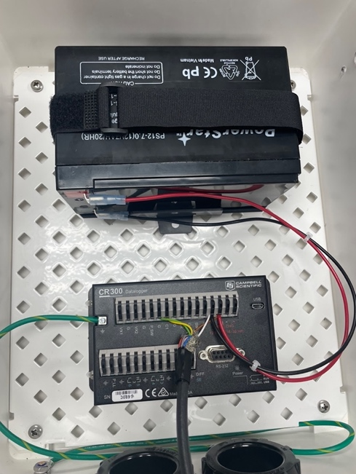
  - Need new wire connectors and a red and a black wire
  - Plug red wire into + BAT
  - Plug black wire into - BAT 12VAC
  - Secure new connectors to other end of the wire
  - Plug black wire into black terminal on battery
  - Plug red wire into red terminal on battery
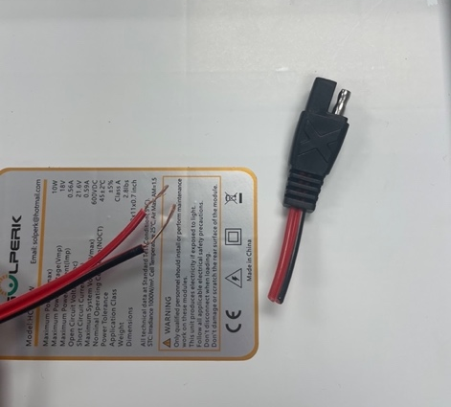
  - Zip tie red and black wires together to clean up enclosure
Figure 7: Battery connected to datalogger
  - See Figure 7
- Cut off end of wire on the cord from the solar panel
  - Strip down ends of cord into 2 separate wires
  - See Figure 8
- Attach compression coupling to top of metal pole
Figure 8: Cut end of wire from solar panel

- Mount housing to tripod using a 1 ¾ inch saddle clamp and reinforcement plate

Equipment to Purchase:
- Wire (For battery)
- Screws (For securing battery holder)
- Bolts (For securing battery holder)
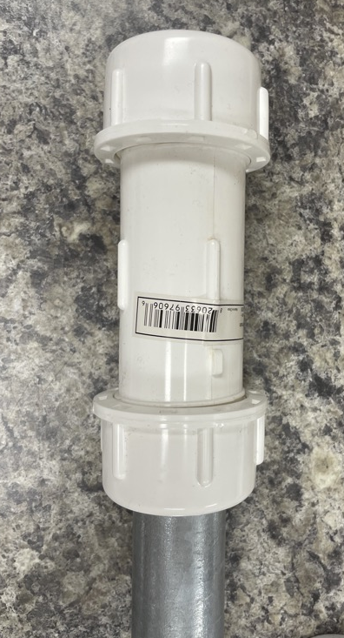
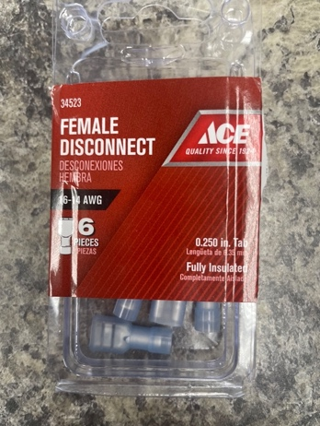
- Female disconnects for wires (To connect wire to battery)
Figure 9: Housing mounted on tripod
- 1 inch compression coupling
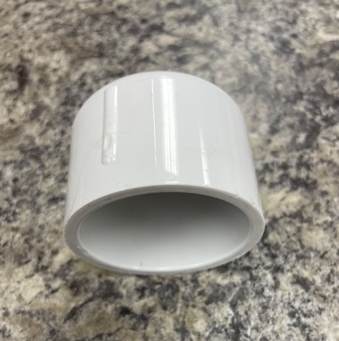
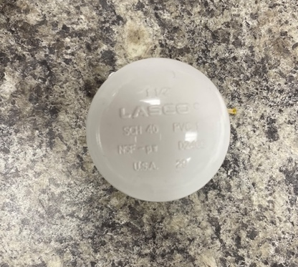
- 1.5-inch cap

- 1 ¾ inch saddle clamps (2)
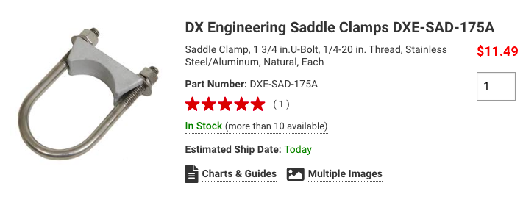
- Reinforcement plate (2)
