Nationwide Eclipse Ballooning Project

Upper Air Sounding

Standard Operating Procedures

August 31, 2022
Carl Spangrude

Adapted from 2017 version
authored by Deborah Ross

Author: ______________________________________________________________________
MSGC Remote Sensing Director Carl Spangrude Date

Approved: ______________________________________________________________________
MSGC Director Angela Des Jardins Date
Table of Contents
A. Purpose and Applicability 2
B. Summary of Method 2
C. Definitions 3
D. Cautions 3
E. Interferences 4
F. Personnel Qualifications 5
G. Equipment and Supplies 6
H. Procedural Steps 7
I. References 13
J. Health and Safety Warnings 13
K. Attachments and Checklists 14

Purpose and Applicability
The purpose of this Standard Operating Procedures (SOP) document is to establish a uniform procedure for GRAW radiosonde initialization and collection of sounding data via balloon among Atmospheric Science teams of the Nationwide Eclipse Ballooning Project. This SOP will aid in ensuring credibility, accuracy, and completeness of all launches and data retrieved. The procedures outlined in this SOP are applicable to all personnel involved in the planning, coordination, preparation, execution, and reporting of upper air soundings.

Summary of Method
The radiosonde is a small, expendable instrument package that is suspended below a balloon filled with helium. As the radiosonde ascends, sensors on the radiosonde directly measure temperature and relative humidity (RH). These sensors are linked to a battery powered radio transmitter that sends the sensor measurements to a sensitive ground receiver at 1-2 second intervals. Pressure, wind speed, and wind direction are also inferred via GPS throughout ascent.

The ascent can last in excess of two hours. During this time, the radiosonde can rise over 30 kilometers (km) and drift more than 250 km from the release point. During the observation, the radiosonde is exposed to temperatures as cold as -95° Celsius (C), RH values ranging from 0 to 100%, and air pressures only a few thousandths of what is found at the Earth's surface. The balloon bursts when it has expanded beyond its elastic limit and a small parachute slows the descent of the radiosonde minimizing the danger to people and property. (Marsh, 2010)

Definitions
NOAA – National Oceanic and Atmospheric Administration
WRF – Weather Research and Forecast
GFS – Global Forecast System
GSF – Graw Simulation File
GS-U – GRAWMET Ground Station Unit
ATCT – Airport Traffic Control Tower
FAA – Federal Aviation Administration
UAS – Unattended Aerial System
Lufft – Lufft brand WS502-UMB smart weather surface station
MSGC – Montana Space Grant Consortium
GPS – Global Positioning System
NOTAM – Notice to Air Missions

Cautions
- Aviation Radio
  - DO NOT operate the radio without a proper antenna attached, as this may damage the radio and may also cause you to exceed FCC RF exposure limits. A proper antenna is the antenna supplied with this radio by the manufacturer or antenna specifically authorized by the manufacturer for use with this radio.
  - Never carry the transceiver by holding the antenna.

- Computers
  - Keep all electrical equipment stored in a cool, dry place. While the computers are being used in the field they may be exposed to adverse conditions. The aerating table has a shelf for the computer to sit out of direct sunlight and other weather conditions.

- Lufft
  - If the equipment is installed incorrectly it may not function and has the potential to fall which could result in sensor failure. If the equipment is not connected correctly it can result in sensor failure due to power surges and can also create an electric shock hazard.

- Balloon
  - Latex balloons are sensitive to light, temperature and oil. The balloons should be stored in a cool, dark place and only removed from their individual plastic bags at time of use. Handle latex balloons only if wearing cloth gloves.

- Helium
  - Improper storage and handling of tanks can lead to degradation and possible malfunction. See Equipment and Supplies (pg. 7) for proper handling and storage techniques.

- Radiosonde
  - While preparing the radiosonde DFM-09, carefully pull out the sensor boom to ensure that the sensor head is not touched. Any contact to skin can leave oil residue which will result in spotty or inaccurate data retrieval.

- GS-U
  - Prior to operation outdoors, the ground station must be earthed with an earthing cable. When the devices are not earthed, there is a hazard for life and limb.
  - Do not use a higher voltage than recommended in the Technical Data (Attachment 5). Otherwise the device may be damaged, and the warranty shall immediately be rendered null and void.

Interferences
- Data Reporting

  - Graph a skew-t plot using the GRAW software during flight to view any problems that may occur. (See Attachment 8)
  - Minimize probability of data loss due to obstructions.
    - Heights of obstructions should be less than tracking antenna if possible.
    - Ensure maneuvering room.
  - Analyze data to detect system noise or signal dropouts.
  - To avoid loss of data, save radiosonde data to both the computer used and to a thumb drive.

- Radiosonde Initialization
- Acclimate the radiosonde to ambient air for 10 minutes before making comparisons. If the comparison values taken from the Lufft surface station are outside +/- 2°C for temperatures, +/- 10% for RH, or +/- 5 mbar for pressure, allow radiosonde to acclimate for another 2 minutes before rechecking; if it fails again, use another sensor.
- Three attempts should be made to properly initialize the radiosonde. If after three attempts the radiosonde is still not properly initializing, discard the radiosonde and attempt initialization with a new one.
- Once initialized, attach radiosonde to hanger with clear view of sky to maintain data reception during fill.
- Confirm any radiosondes not initialized for flight have been turned off.

- GRAWMET
  - Exact GPS coordinates allow the time packets to arrive almost immediately. If the coordinates are for the broad region of flight it takes time for GRAWMET to find the radiosonde and can result in lost data. *Note – North America is negative longitude

- Balloon Fill
  - The balloon can experience wear at any stage of its handling and should be consistently checked for damage. If the balloon is thought to be damaged in any way a new balloon should be implemented. There are times when no apparent damage is visible until fill has begun, in this case a new balloon still must be used at the cost of wasted helium.

Personnel Qualifications
This SOP is written specifically for those individuals who are participating on an Atmospheric Science team of the NEBP. There is no certification necessary, but a basic knowledge of electronics and the structure of the atmosphere is helpful. This SOP is designed to be a user guide that, if followed correctly, will produce a successful radiosonde field campaign launching multiple soundings to produce a viable data set for integration into the NEBP analyses.

Equipment and Supplies
- Helium

1.1 Helium Storage

- Store helium tanks upright at temperatures below 125 °F (52 °C).
- The storage area should be secure, ventilated, and able to protect the tanks from sunlight and the weather.
- Secure tanks with chain, ropes, or straps so they do not fall.
- Avoid blocking emergency exits and traffic areas.
- Do not store helium tanks near corrosive materials, such as salt, or materials that may catch fire. Store helium tanks only with other compatible substances.
1.2 Helium Transport

- Cylinders transported by wheeled truck must be fastened securely in an upright position so that they will not fall or strike each other.
- Cylinders should not be transported without safety caps. A cylinder’s cap should be screwed all the way down on the cylinder’s neck ring and should fit securely. Do not lift cylinders by the cap. The cap is for valve protection only.
- Cylinders should NOT be transported with the regulator attached to the cylinder.
- Always use a cylinder cart to move compressed gas cylinders. Refrain from sliding, dragging, or rolling cylinders on their edge.
- Only one cylinder should be handled (moved) at a time. (Safety)

  - Helium Use

- Use cylinders in an upright position and secure them to prevent toppling. If there is nothing to secure the cylinder to then laying the helium on its side is acceptable. Always ensure helium tank is pointed in a safe direction when laying horizontally.
- Do not attempt to catch a falling cylinder; move out of the way.
- The valve on high-pressure balloon gas cylinders should never be opened unless the appropriate filling kit is attached.
- Check the valve outlet is free from contamination before fitting the filling kit.
- Slowly open the cylinder valve by turning it in an anti-clockwise direction. Listen for any obvious leaks. If there is a leak, turn off the valve, release any excess gas in the filling kit and check you have fitted the filling kit correctly.
- The cylinder valve should be closed when the cylinder is empty or not in use. The cylinder valve is closed by turning it in a clockwise direction, hand tight only.
- Remove the regulator if moving the cylinder any distance or ceasing use. Before removing the regulator, turn off the cylinder valve and release the pressure in the kit.

- For list of remaining equipment see Attachment 1.

Procedural Steps
Grawmet Setup:
- Open Grawmet 5.15
- Click on the tab to the left of the Start tab
- Click on General Settings
- Click on Program Settings
- Select the Profile Data Table, Raw Data Table and Skew-T Diagram
- Click OK
- Click the back arrow

- Week prior to field campaign
- Confirm launch site
- Confirm FAA coordination
- Confirm helium acquisition or delivery time/location
- Confirm rental cars if traveling to launch site
- Confirm frequency separation and timing schedule
- Disable auto-updates on all ground station computers
2) 48 hours prior to field campaign
- Pack all necessary materials and confirm radiosonde launch checklist is complete
- Charge all computers and GS-Us fully the night before beginning launches
- Record helium in tank pressure in: pounds/square inch (psi)
- Record balloon mass in: grams (g)
- Record payload mass in: grams (g)
- Record helium required (to achieve 5 m/s average rise rate, using NEBP helium fill calculator) in: pounds/square inch (psi)
- Confirm predicted flight path trajectories with NEBP Atmospheric Science Leadership team
- File a NOTAM with the FAA if necessary
- Inform ATCT of flight operations 10 minutes prior to release time including launch location and expected maximum altitude
- If no ATCT, attempt to notify local Flight Service Station or airport’s tower
- Tie parachute, unwinder, and loop for balloon attachment (see attachment 7 on knots).
  - 2 feet between top of parachute and the balloon
  - 1 foot between parachute to unwinder
3) Pre-flight (day of launch)
- Confirm batteries are charged
- Confirm packing checklists are complete, field checklists and SOP are available and accessible at launch site
4. Flight
General tips:
- Set up the Lufft weather station as you arrive at the launch site and let it record data until termination of the final balloon is confirmed.
- Make sure none of the boxes in the balloon burst/termination section of the GRAWMET options page are checked.
- If unsure the radiosonde is receiving GPS, check the bottom board. There is a green LED that will flash if GPS is being received by the sonde.
- Initial location conditions (latitude, longitude, and altitude) are EXTREMELY important for the radiosonde to receive GPS. Make sure they are as accurate as possible. Consider using a handheld GPS unit to determine position.
- DO NOT release the balloon without confirmation of data being received.
- Let the radiosonde acclimate to the environment for at least 10 minutes prior to flight.
- Before release, confirm radiosonde is within 2 °C, 10% RH, and 5 mbar of the surface reference values (Lufft).
Record Initial Values
Use the ‘tab’ key to navigate through each field and record initial values (leave cloud information blank):
- Pressure
mb/hPa
- Temperature
°C
- Humidity
%
- Wind Direction
°
- Wind Speed
m/s
- Cloud Lower Limit (not required)
- Cloud Group (not required)
/ / / / /
- Ground Altitude
m
- Launch Latitude
°
- Launch Longitude
°
- Radio Frequency
MHZ
Lufft Procedure:
- Set up the Lufft weather station as you arrive at the launch site and let it record data until termination of the final balloon is confirmed.
  - IMPORTANT: Always ensure the north arrow on top of the Lufft sensor is pointing to true north
- If possible, use a solar panel to charge the Lufft battery.
- Set up the Lufft weather station 10 m away from large features and let values start coming in before starting GRAWMET.
Helium Fill Prediction Notes:
- Open the ‘Helium Fill’ Python code in Command Prompt and answer the prompts to receive a fill prediction range. Use the lower value in the range provided.
- When prompted for ‘burst altitude’ or ‘rise rate’, select rise rate and input “5.0” (m/s).
GRAWMET Procedure:
- BEFORE STARTING GRAWMET:
Open the radiosonde - careful to not touch the end of the sensor. The initialization cable can be plugged in to the sonde. There is a section on the end of the sonde near the power switch that is cut to fit the cable.
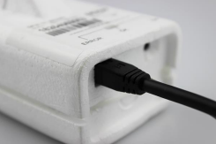
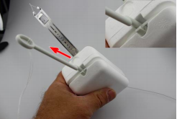

- Turn on GS-U
- Open GRAWMET 5.16 software
- Click on the tab to the left of the Start tab
- Open General Settings
- Click on the Program Settings tab
- Click on the Communications tab
- Click Detect under Groundstation
- Plug in the radiosonde (do not switch it on yet)
- Click Detect under Com Ports
- Click the back arrow
- With GRAWMET 5.16, simulation must be run before sounding (Documents > Grawmets > Sample Flight > .GSF file)
- Click Sounding/Simulation in the ribbon near the top of the screen
- Click Initialize Radiosonde (Wizard is recommended)
- After initialization completes, click the arrow next to Advanced and click Set Frequency
- Set frequency according to frequency allocation list or find open channel free of interference
- Click apply
- Input ground conditions into their respective fields (Exclude release pressure, pressure correction, cloud group, and cloud lower limit)
- Enter Latitude, Longitude and Altitude
- Click Start Sounding
*Make sure these values are as accurate as possible to insure immediate data retrieval. Can be updated during flight if necessary
- Click Next through additional windows, then Apply
- Turn on the radiosonde and then unplug the initialization cable from the sonde
*Hold radiosonde power button until solid yellow light appears (Red: error, Yellow: on)
- Once initialized, attach the radiosonde to the acclimation table. Confirm data is received before launch
- Click on Start Launch Manually if detected frequency not engaged within 30 seconds
- Wait for sounding to complete (10 minutes of continuously decreasing altitude), then click Terminate
- Wait for data to finish compiling, then save all the data reports as shown in “Post Flight” on Page 11

5. Post Flight
GRAWMET Procedure:
- Save Profile data table (Reports > Save as .txt) using the naming convention:
  - LocationAcronymFlightNumber_hhmmUTC_ddmmyy_Computer_profile
    - Example: Profile data from flight #5 launched from San Antonio (example of established acronym= SA) at 17:06 UTC on October 14th 2023 with computer named “Montana1” would be saved EXACTLY as follows:
      - SA5_1706UTC_101423_Montana1_profile

- Save BOTH sides of the sensor/GPS data table. This is located in the visualization tab. Windows to name and locate saved raw data files (1 and 2) pop up individually. (Save active view as .txt)
  - LocationAcronymFlightNumber_hhmmUTC_ddmmyy_Computer_raw1
  - LocationAcronym_FlightNumber_hhmmUTC_ddmmyy_Computer_raw2
    - Example: Raw data (files 1 and 2) from flight #12 launched from Buffalo (example of established acronym= B) at 10:12 UTC on April 8th 2024 with computer named “NY1” would be saved EXACTLY as follows:
      - B12_1012UTC_040824_NY1_raw1
      - B12_1012UTC_040824_NY1_raw2

- Save Skew-T as .JPG
  - LocationAcronymFlightNumber_hhmmUTC_ddmmyy_Computer_skewt
    - Example: Skew-T from flight #30 launched from Lakeview (example of established acronym= LVW) at 00:00 UTC on August 1st 2022 with computer named “Intel1” would be saved EXACTLY as follows:
      - LVW30_0000UTC_080122_Intel1_skewt

- Backup GSF data (Documents>Grawmet5>Archive) – Leave name as default
- Backup BUFR data (Documents>Grawmet5>Reports) – only save 502 format files
  - LocationAcronymFlightNumber_hhmmUTC_ddmmyy_Computer_bufr
    - Example: BUFR file from flight #2 launched from Conway (example of established acronym= CWA) at 01:59 UTC on June 30th 2023 with computer named “Arkansas_laptop” would be saved EXACTLY as follows:
      - CWA2_0159UTC_063023_Arkansas_laptop_bufr

- Save the Radiosonde Sounding Overview Form
  - LocationAcronymFlightNumber_hhmmUTC_ddmmyy_Computer_skewt
    - Example: Overview form for flight #10 launched from Roswell (example of established acronym= RNM) at 12:12 UTC on January 2nd 2024 with computer named “GS-1” would be saved EXACTLY as follows:
      - RNM10_1212UTC_010224_GS-1_overview
- Upload each of the above flight data to external hard drive after every flight
- Put equipment away neatly, clear workspace of refuse, and prepare for next launch
Lufft Weather Station Procedure:
- Save Lufft data (.dat) to a computer using PC400 software (Collect Data tab)
  - LocationAcronym_ddmmyy_lufft
    - Example: Lufft data from Bozeman (example of established acronym= BM) valid from April 8th-10th 2024 would be saved EXACTLY as follows:
      - BM_041024_lufft

Move all data to a localized folder. Name the folder using the launch date.
  - 062922 Name of folder
    - Example: All data from June 29, 2022.

Troubleshooting:

- Radiosonde
  - Attempt initialization no more than three times before using a new radiosonde.
  - Make sure to plug radiosonde into computer before starting GRAWMET software or powering the radiosonde on.
- GRAWMET
  - If the error “Does not recognize radiosonde type” is appears, navigate to General Settings, then Program Settings, then the Communications tab. Click Detect under COM ports. If this fails, try reinitializing, and check the COM ports again. Remember to shut down GRAWMET between each initialization to minimize chance of software error.
- Data
  - Raw data not received – Check all cable connections between the GS-U, laptop, and radiosonde. Make sure each cable is plugged in properly at the computer, at GS-U, antenna, and radiosonde. Next try reinitializing the radiosonde. If raw data still fails to propagate, attempt to reinitialize total of three times, if this fails discard and use a new sonde.

  - Raw data is patchy – Check the direction the balloon is traveling and reorient the antenna to maximize signal transmission strength. Try a few different placements of the antenna, and avoid placement near large metal objects such as a helium tank or vehicle.

- GPS
  - If raw data is being received but GPS is not:
    - First check GPS values (NEGATIVE SIGNS MATTER).
    - Move the GS-U as far from the computer/sonde as possible.
    - Eliminate any obstructing metal objects around the sonde.
    - Wait for between 15-30 minutes with sonde placed in view of satellites to see if it begins filling (consider replacing depending on time requirements).
    - Check ground connections are correct.
    - Check bottom of radiosonde, if light is flashing then the sonde is receiving GPS but no data is being received by Grawmet. Double check the radio and connections and the initial condition GPS.
    - Reinitialize the sonde. Try using a different USB port on the computer.
    - Attempt initialization no more than three times before discarding the sonde and trying a new one.

References
1. Marsh, S. (2010). National Weather Service Manual. (http://www.nws.noaa.gov/directives/sym/pd01014001curr.pdf)

2. Safety, E. H. (n.d.). Compressed Gas Cylinder Storage and Handling.

3. COOPERATIVE HURRICANE UPPER-AIR STATIONS (CHUAS) RADIOSONDE OBSERVING SYSTEM (CROS) AND GRAW GPS RADIOSONDE - CHUAS RADIOSONDE HANDBOOK - EHB 9-756 Rev D, October _ 2016.pdf

4. GRS-KD-0002-en_V05.12_GRAWMET_User Manual.pdf

Health and Safety Warnings
      - Balloon Fill
        - Helium is a compressed gas that should be used with caution (see Equipment and Supplies [pg. 7] for usage outline and Attachment 6 [pg. 25] for transportation regulations).
        - Latex Balloon – Latex is a common allergen. If an allergy is known, depending on the severity, keep distance from the balloon and all filling equipment
- Cotton gloves should always be worn while handling the balloon. Static electricity can easily burst balloons resulting in wasted helium

      - Weather
        - Do NOT fly during poor weather conditions that have the potential for lightning. If there is a question about the weather conditions, reference the sky watcher chart (see Attachment 3).

      - Lufft
        - The Lufft surface station has exposed battery terminals and can be an electric shock hazard if not hadled with caution. Once battery terminals are connected and the unit is powered up the front cover should be latched closed to protect from electric shocks and damage to unit.

Attachments and Checklists

Attachment 1 (per launch) – Radiosonde Launch Checklist

Radiosonde Launch Checklist
Graw radiosonde (+ backup radiosondes)
Laptop for ground station (with charging cables)
iPad & cables (Lufft)
Power inverter
Handheld GPS
Batteries (AA, AAA, 9V)
String (for radiosonde connection)
First aid kit
Black Tool Box:
Crescent wrench (Large & Small)
Scissors
Duct Tape
Teflon Tape
Carabiners
Wire Cutters
Pliers
Tape Measure
Electrical Tape
Lighter/Matches
Zip Ties (x10+)
Balloons (600g)
Dereeler & Parachute
Gloves for balloon handling (x4+)
Tarp
Helium tanks
Regulator (+ backup regulator)
Weights
Clipboard, pens/pencils
Fish scale
Aviation radio
Lufft weather station
Masking tape
GSU
Extension cord
Plug strip
Water
Field Site Items:
Tent
Table
Chairs
Lights/headlamps
Binoculars
PPE
Compass

Attachment 2 – FAA Regulations

§ 101.1 Applicability.
Link to an amendment published at 81 FR 42208, June 28, 2016.
(a) This part prescribes rules governing the operation in the United States, of the following:
(1) Except as provided for in § 101.7, any balloon that is moored to the surface of the earth or an object thereon and that has a diameter of more than 6 feet or a gas capacity of more than 115 cubic feet.
(2) Except as provided for in § 101.7, any kite that weighs more than 5 pounds and is intended to be flown at the end of a rope or cable.
(3) Any amateur rocket except aerial firework displays.
(4) Except as provided for in § 101.7, any unmanned free balloon that -
(i) Carries a payload package that weighs more than four pounds and has a weight/size ratio of more than three ounces per square inch on any surface of the package, determined by dividing the total weight in ounces of the payload package by the area in square inches of its smallest surface;
(ii) Carries a payload package that weighs more than six pounds;
(iii) Carries a payload, of two or more packages, that weighs more than 12 pounds; or
(iv) Uses a rope or other device for suspension of the payload that requires an impact force of more than 50 pounds to separate the suspended payload from the balloon.
§ 101.7 Hazardous operations.
(a) No person may operate any moored balloon, kite, amateur rocket, or unmanned free balloon in a manner that creates a hazard to other persons, or their property.
(b) No person operating any moored balloon, kite, amateur rocket, or unmanned free balloon may allow an object to be dropped therefrom, if such action creates a hazard to other persons or their property.

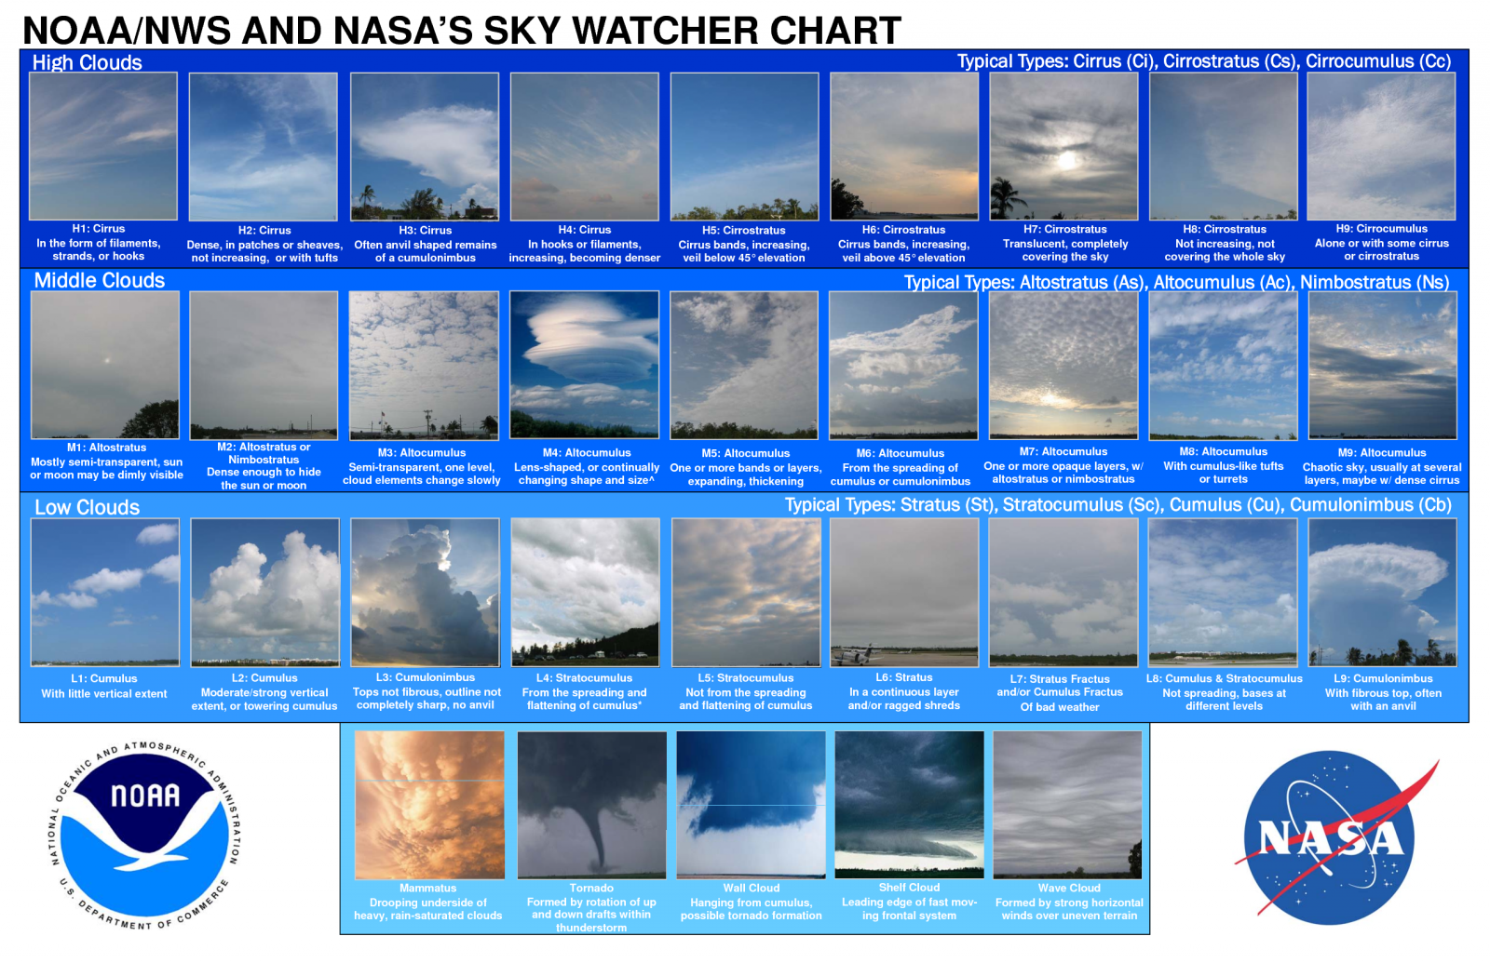
Attachment 3 – Cloud Chart

Attachment 4 – Lufft Weather Station Installation

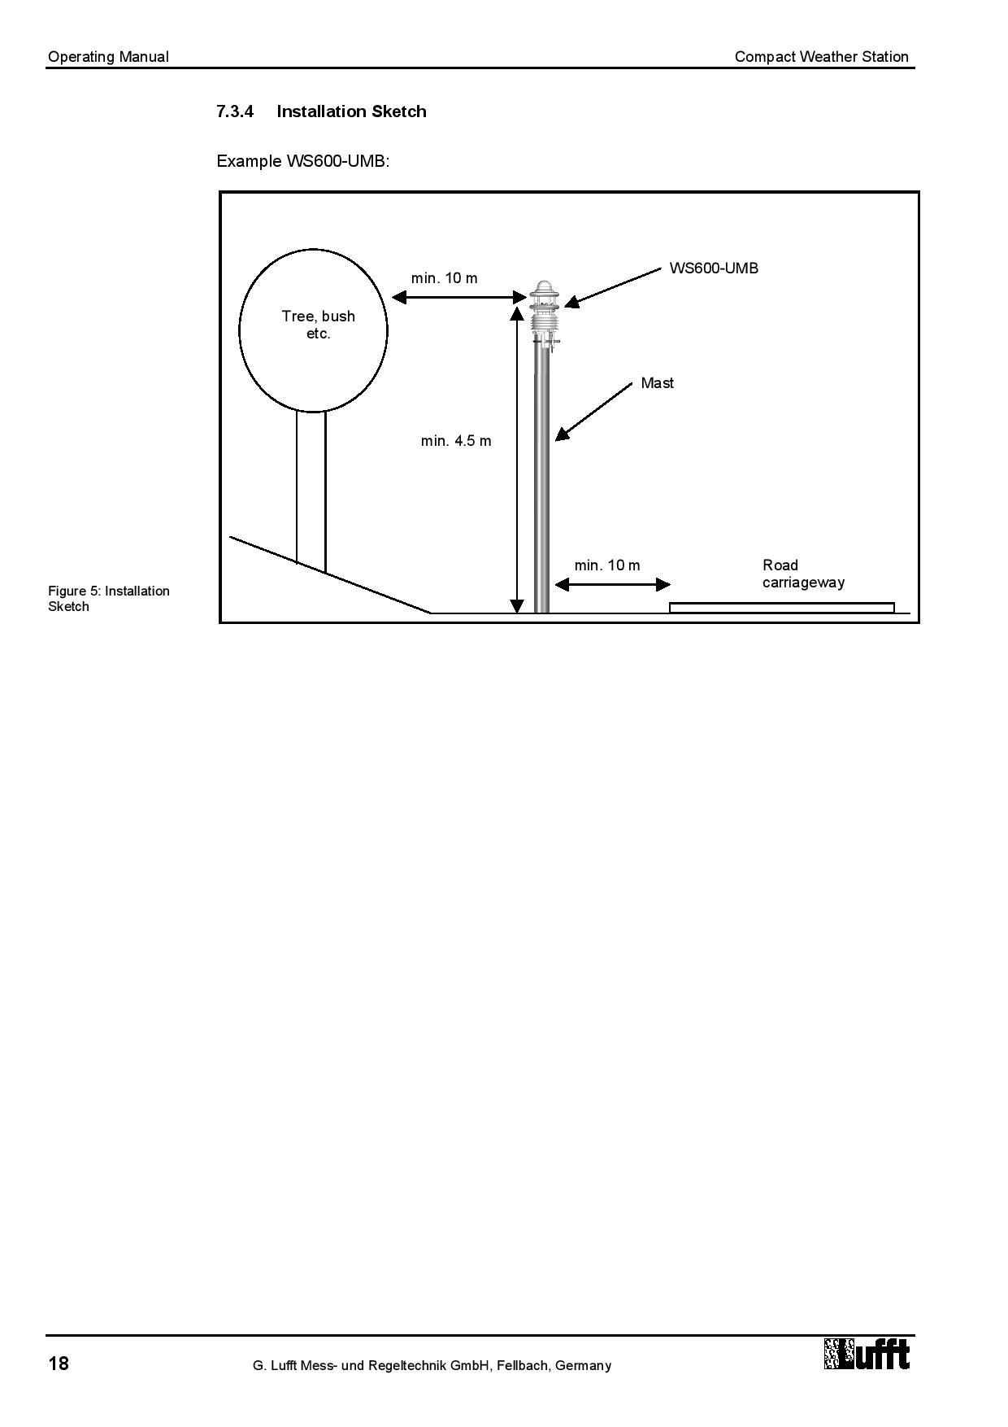

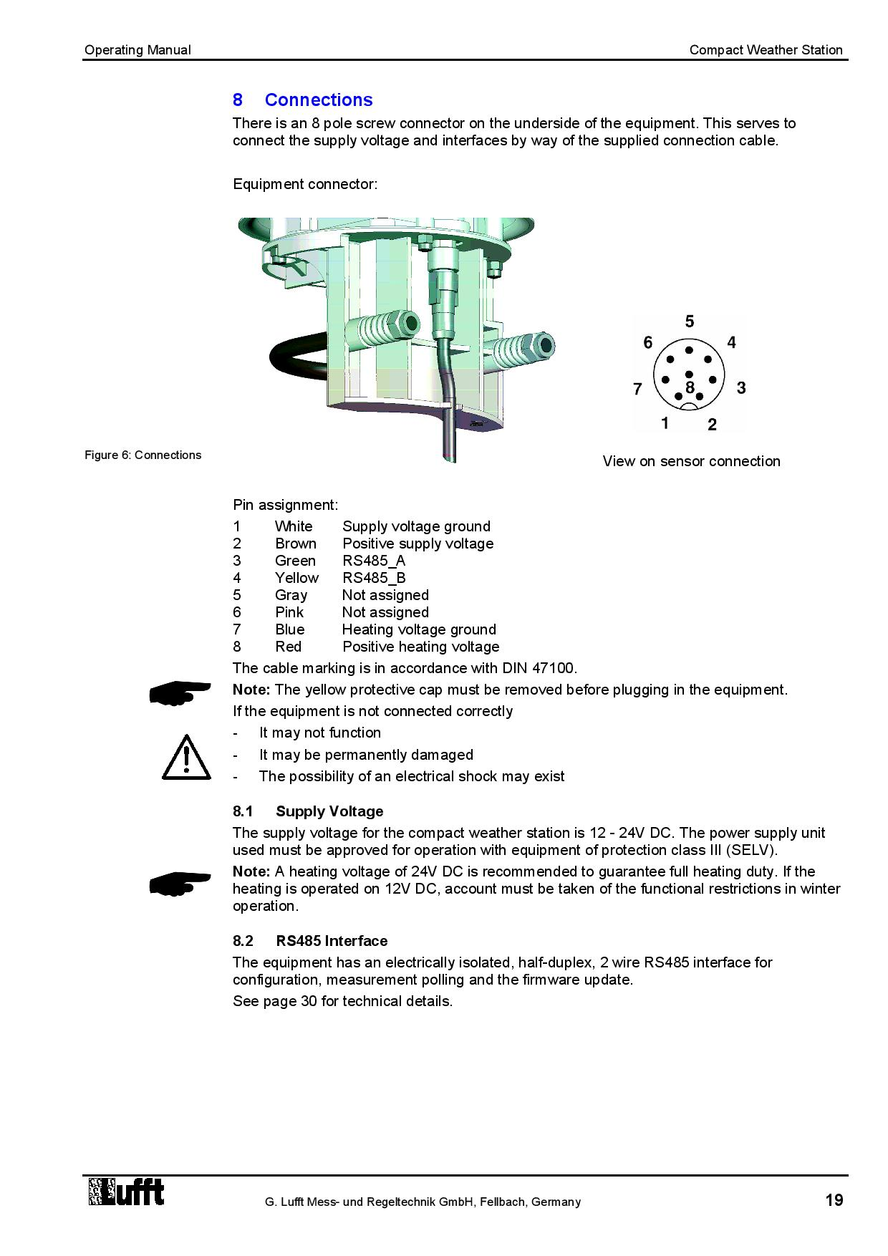
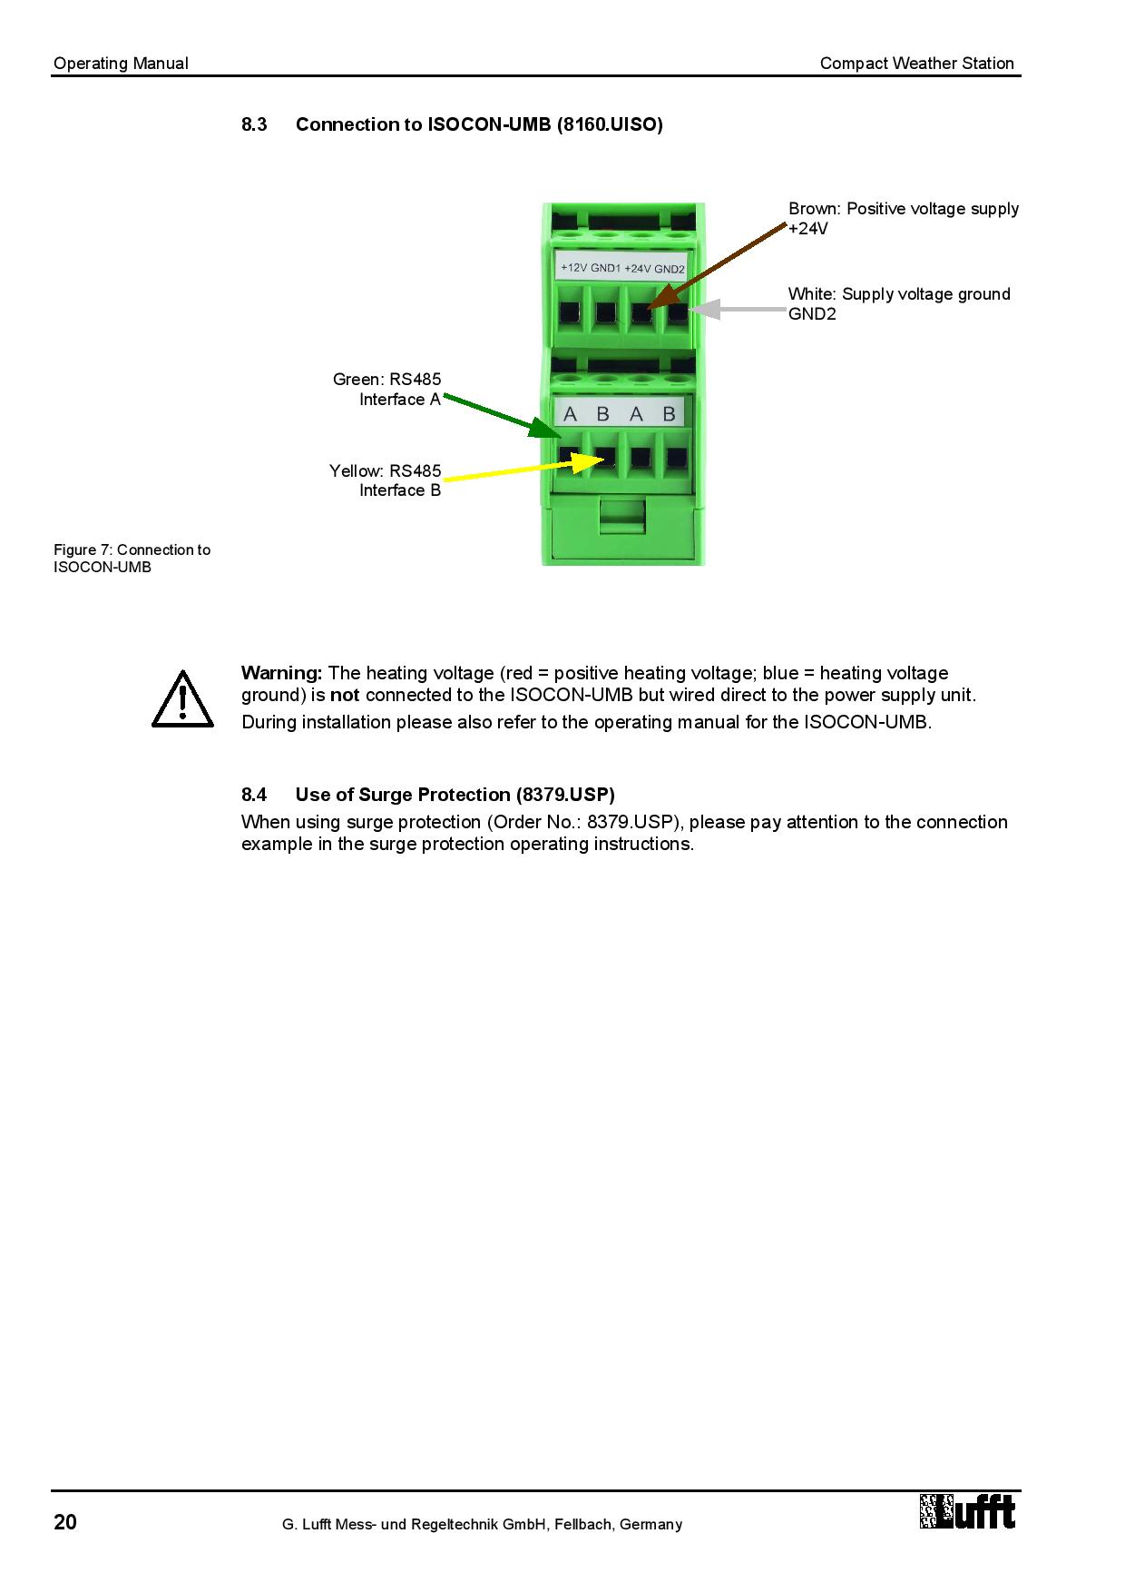
Attachment 5 – GS-U Setup

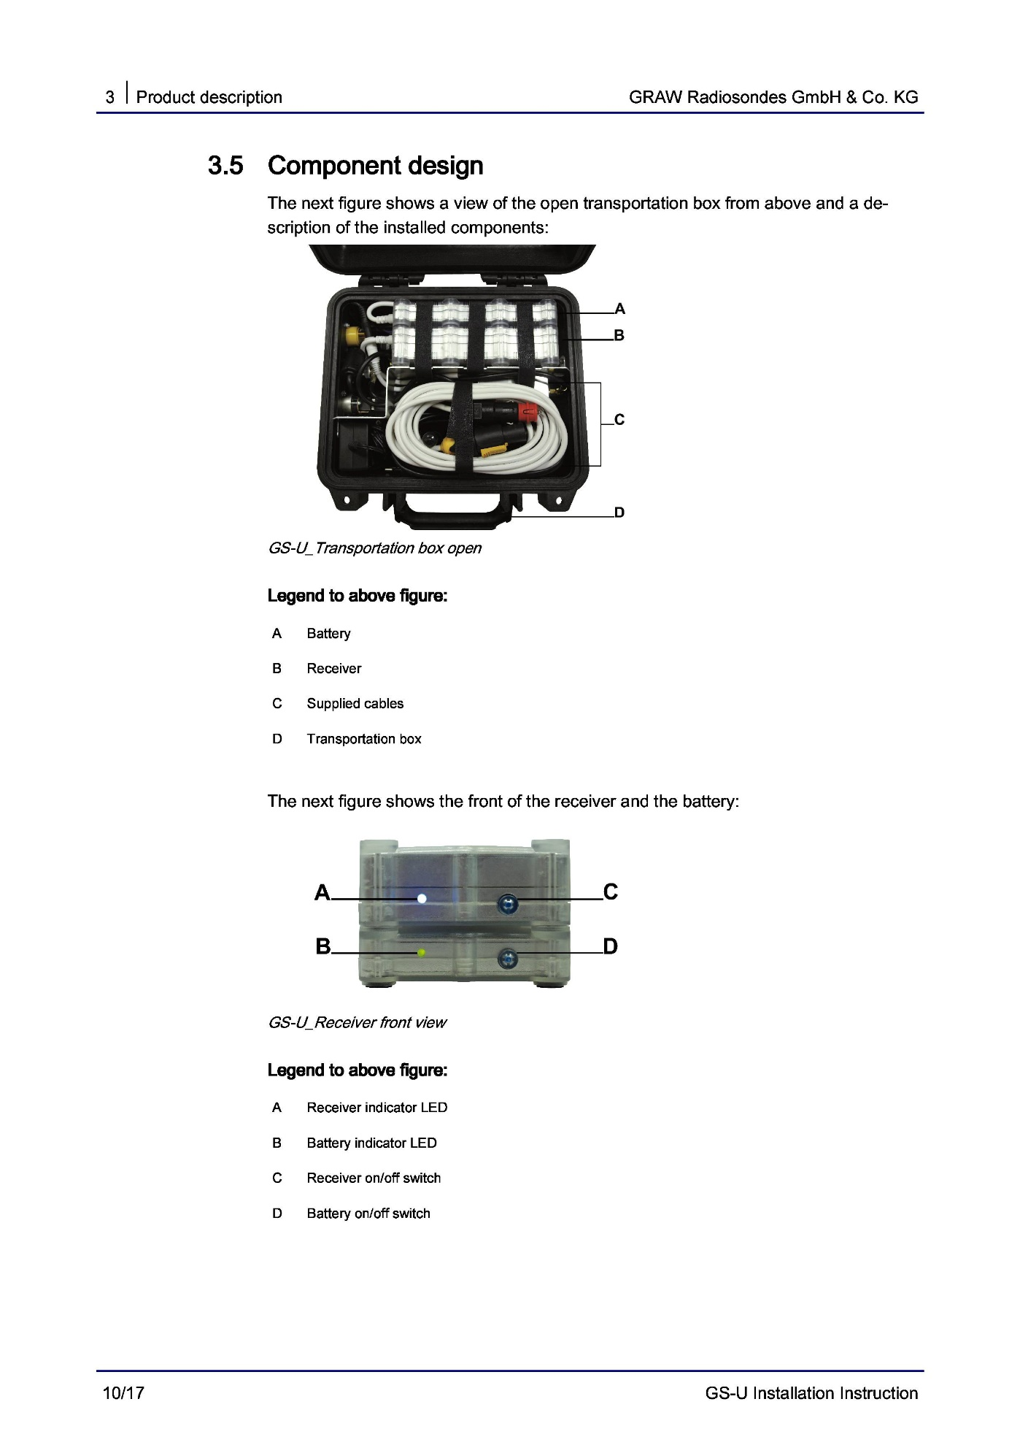

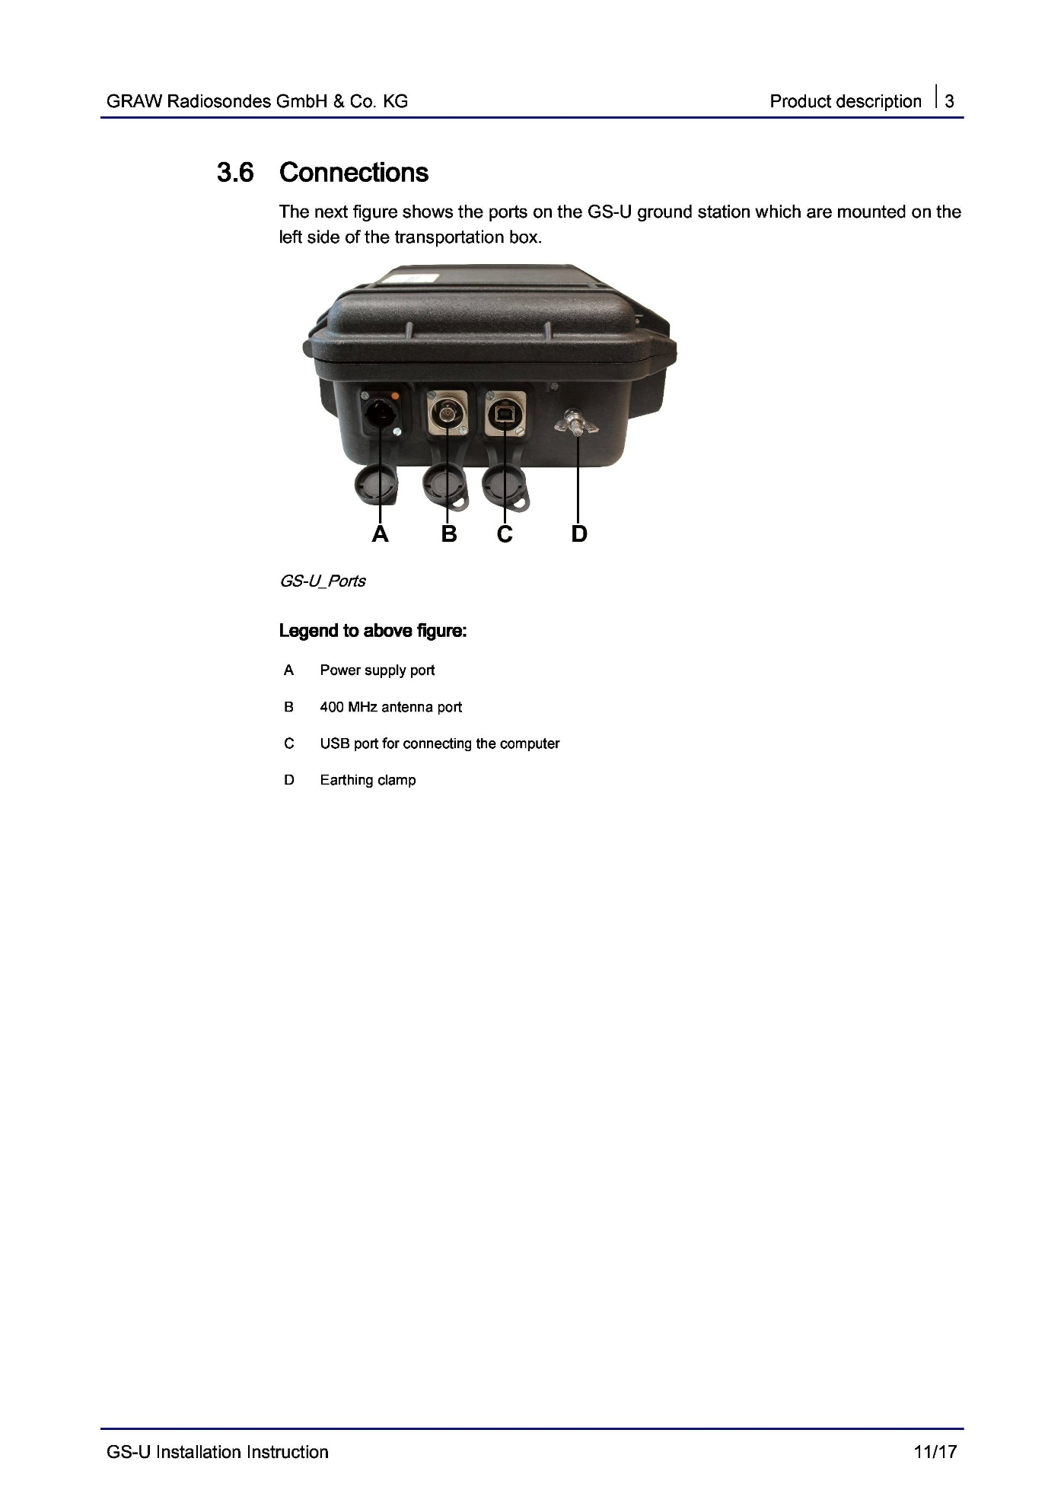
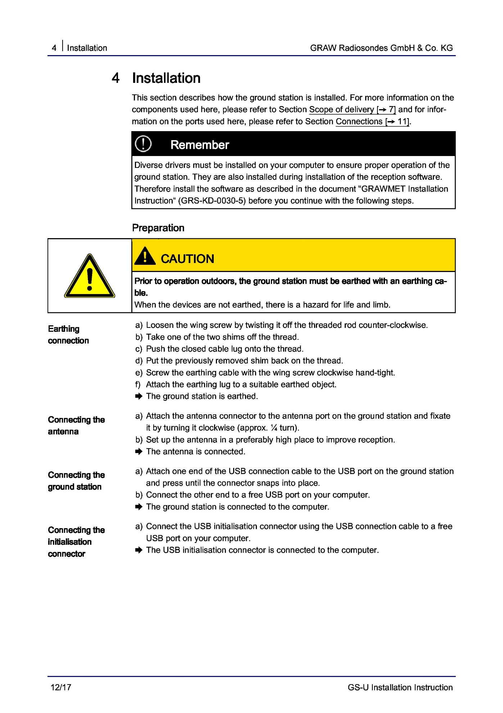
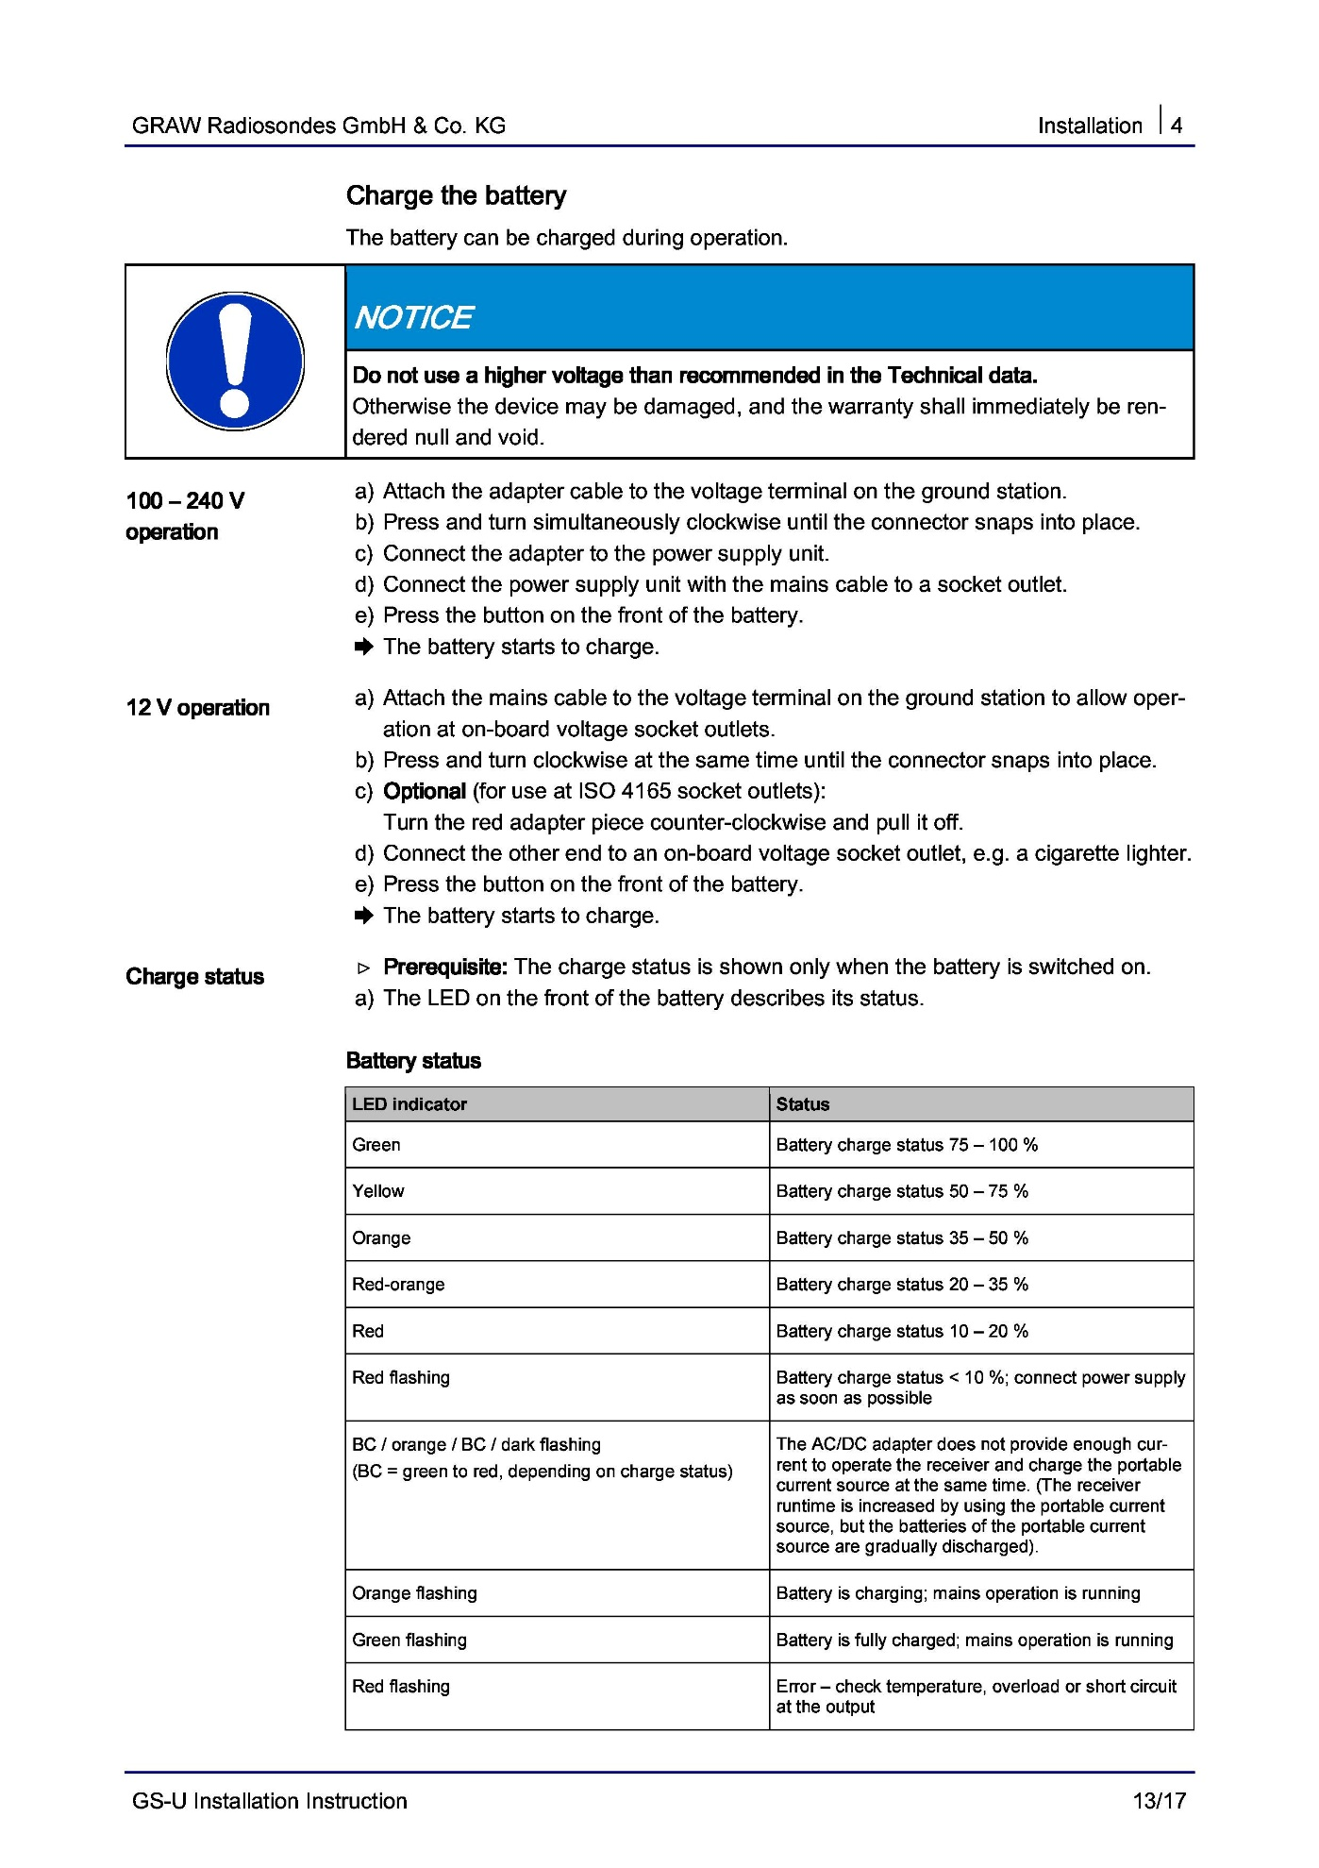
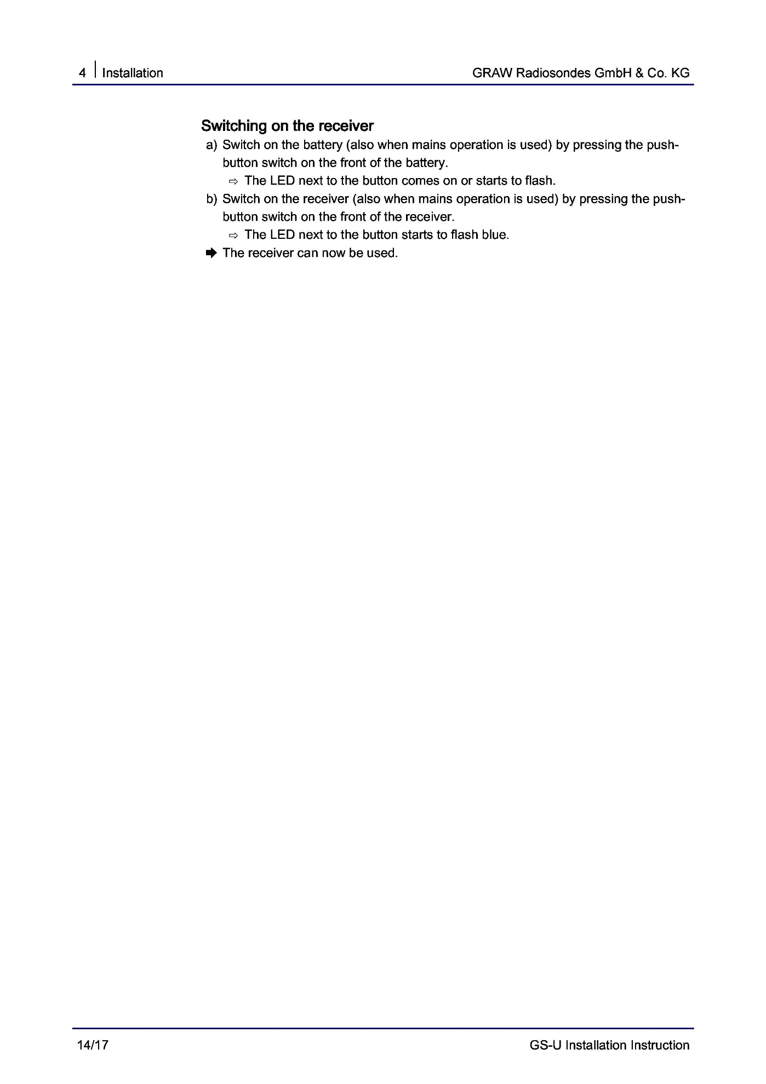
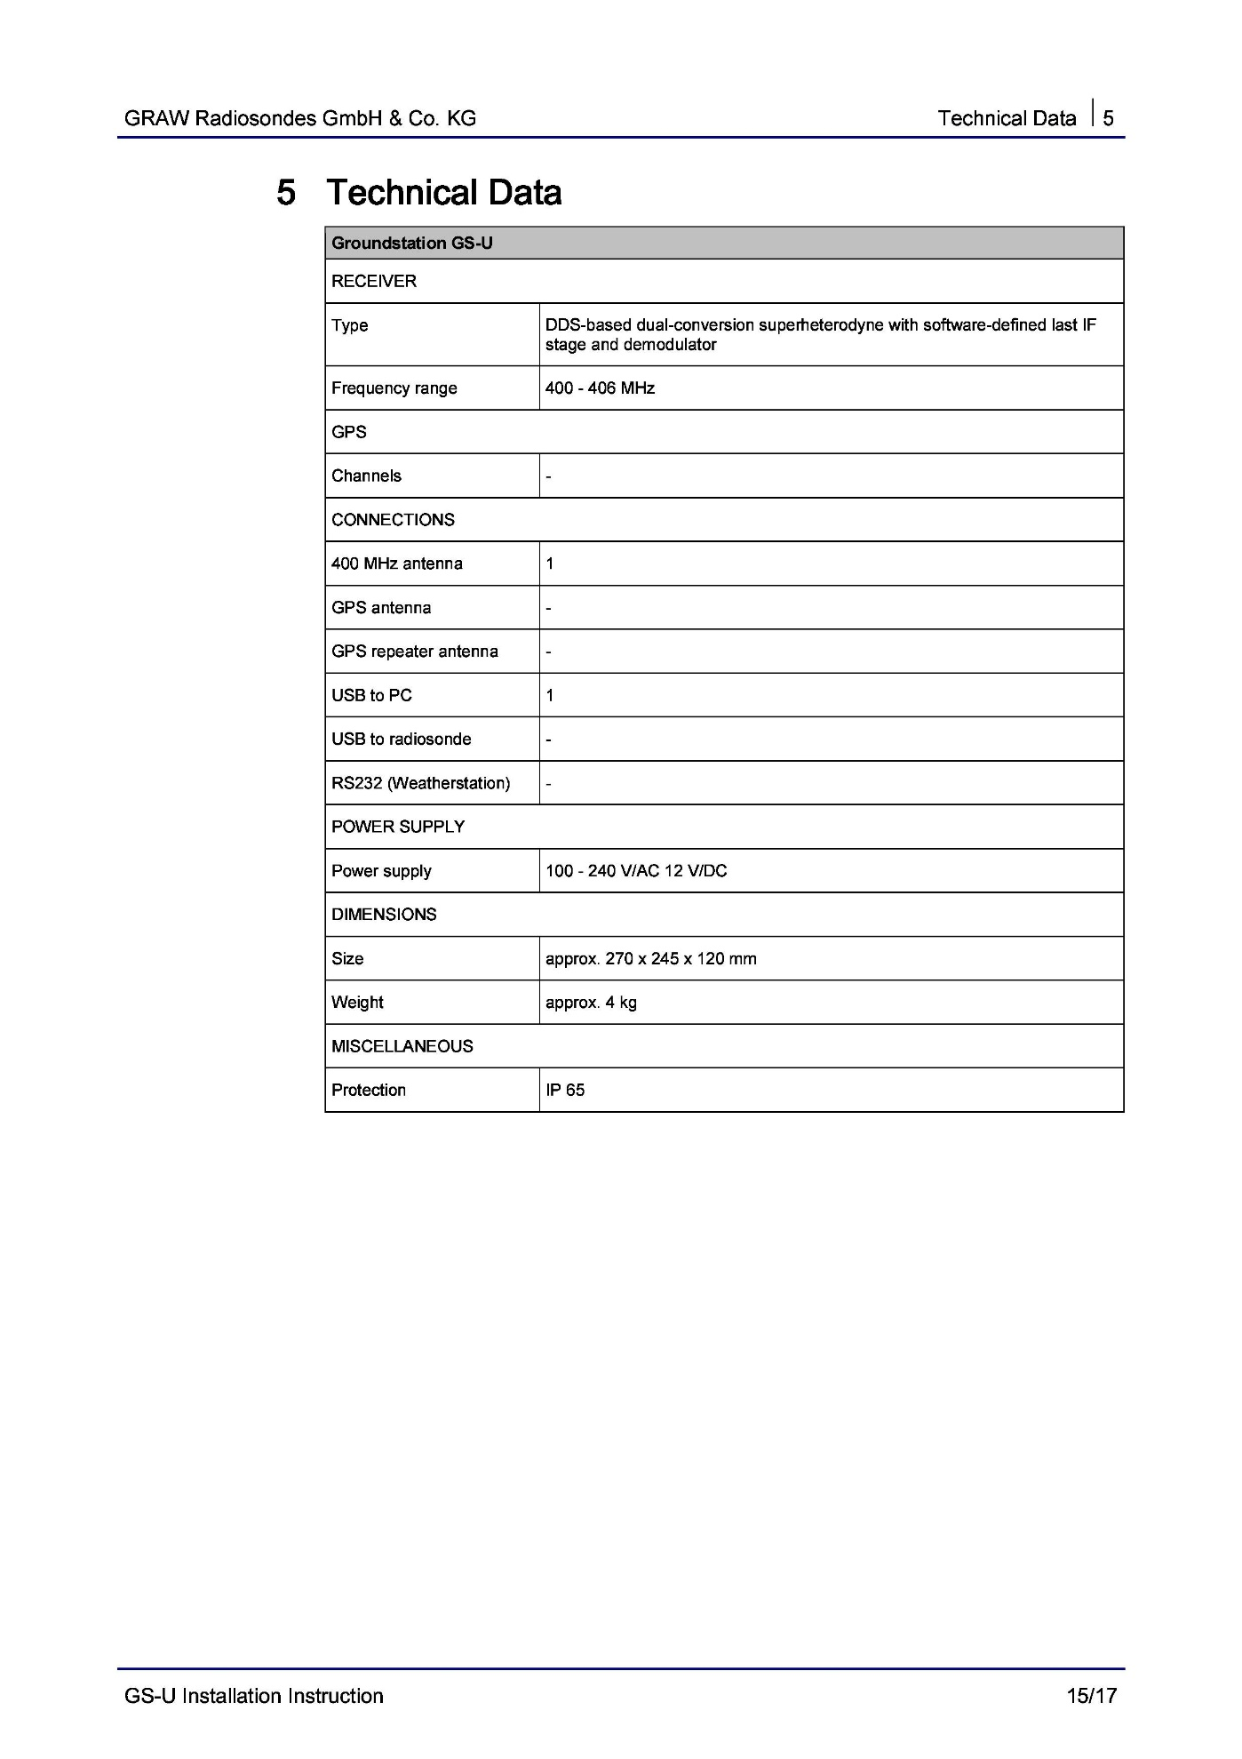
Attachment 6 – Helium Transportation

Transportation of Helium
Compressed helium in a tank (or cylinder) is a division 2.2 material and is thus designated a hazardous material or dangerous good by the Department of Transportation (DOT) as defined by 49 CFR 172.01. This means that the transportation of compressed helium is regulated and therefore it is important that the high altitude ballooning community understand these regulations and how compressed helium can be transported for balloon launches legally.
The regulations for transporting hazardous materials typically apply to commercial transport. Since the ballooning community transports compressed helium with the balloons for HAB launches we meet an exemption under “Materials of Trade.” This exemption can be found under eCFR Title 49 → Subtitle B → Chapter I → Subchapter C → Part 173 SHIPPERS—GENERAL REQUIREMENTS FOR SHIPMENTS AND PACKAGINGS, subpart A 173.6. The short of it is if you comply with the regulations under the “Materials of Trade” (summarized below) you can transport a certain amount of compressed helium legally:
- Always transport the high altitude balloons in the same vehicle as the helium tanks
  - [Recommendation] Carry the “Materials of Trade” regulations within the transporting vehicle
  - [Recommendation] Carry the invoice from place of purchase within the transporting vehicle
- Each individual tank (or cylinder) of helium my not exceed 220 pounds (100 kg)
- The tanks (or cylinders) of helium can’t have a leaks
- The tanks (or cylinders) of helium must be secured. Upright is recommended, but since vapor lock is not an issue with helium they may secured horizontally
- The tanks (or cylinders) of helium must be labeled with a (green) helium hazmat label
- The tanks (or cylinders) must be well ventilated (i.e. in a pickup truck and not in an enclosed vehicle
- Whomever is driving the vehicle must be made aware the he or she is transporting compressed helium and the total weight of the tanks (or cylinders) and its contents (helium) may not exceed a total weight of 440 pounds (200 kg)
Using a common K type tank (3AA 2265 – 2650 cu inches) for example would allow the transport of ~3.6 tanks of compressed helium.
For those of you interested in the details of the regulations as they relate to the HAB community, please see below:
1.
"When transported by motor vehicle in conformance with this section, a material of trade (see §171.8 of this subchapter) is not subject to any other requirements of this subchapter besides those set forth or referenced in this section.
[From §171.8] Material of trade means a hazardous material, other than a hazardous waste, that is carried on a motor vehicle –
(3) By a private motor carrier (including vehicles operated by a rail carrier) in direct support of a principal business that is other than transportation by motor vehicle.”
Translation: as long as HAB balloons are in the same transporting vehicle as the helium tanks you are in compliance of §171.8.
2.
"A Division 2.1 or 2.2 material in a cylinder with a gross weight not over 100 kg (220 pounds), in a Dewar flask meeting the requirements of §173.320, or a permanently mounted tank manufactured to the ASME Code of not more than 70 gallon water capacity for a nonliquefied Division 2.2 material with no subsidiary hazard."
Translation: Individual vessels containing helium cannot weight over 100 kg (220 lbs). Compressed helium comes in the form of tanks (or cylinders). The tanks BOREALIS often uses are type K – 3AA 2265 with a Water carrying capacity of about 2650 cu. in. (varies by manufacturer) which relates to a weight of about 120 pounds which is compliant.
3./4.
"(b) Packaging. (1) Packagings must be leak tight for liquids and gases, sift proof for solids, and be securely closed, secured against shifting, and protected against damage." and "(3) Outer packagings are not required for receptacles (e.g., cans and bottles) that are secured against shifting in cages, carts, bins, boxes or compartments."
Translations: Make sure the tanks are leak free and are secured appropriately.
5.
"(5) A cylinder or other pressure vessel containing a Division 2.1 or 2.2 material must conform to packaging, qualification, maintenance, and use requirements of this subchapter, except that outer packagings are not required. Manifolding of cylinders is authorized provided all valves are tightly closed." and "(3) A DOT specification cylinder (except DOT specification 39) must be marked and labeled as prescribed in this subchapter. Each DOT39 cylinder must display the markings specified in 178.65(i)."
Translation: Make sure the tank is labeled with a green hazmat label
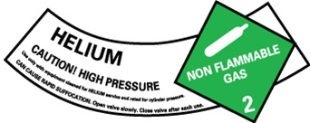
7.
“(4) The operator of a motor vehicle that contains a material of trade must be informed of the presence of the hazardous material (including whether the package contains a reportable quantity) and must be informed of the requirements of this section.
(d) Aggregate gross weight. Except for a material of trade authorized by paragraph (a)(1)(iii) of this section, the aggregate gross weight of all materials of trade on a motor vehicle may not exceed 200 kg (440 pounds).”
Translation: The operator of the vehicle must be made aware of what they are transporting. The total weight of the packages (tanks) plus contents (compressed helium) may not weigh over 440 pounds. Assuming the K type tanks described above, that would allow for the transport of 3.6 (3) tanks of compressed helium.

Attachment 7 – Unwinder and Parachute Knots

Attachment 8 – What to Look for in a Skew-T plot
Skew-T Guide by Colten Hoffmeier

Introduction:
This guide is intended to help new interns learn what a Skew-T is and how to read them. A Skew-T is used by meteorologists during a weather sounding to determine what current and potential future weather looks like. They are gathered via radiosondes attached to weather balloons that you will become familiar with. At the time of this writing, the software we use for Skew-T plots is GRAWMET. The general information that we gather from this includes wind speed, wind direction, relative humidity, dew-point temperature, and actual temperature. With this we can determine several conditions that are covered in the Relevant Information section of this paper.

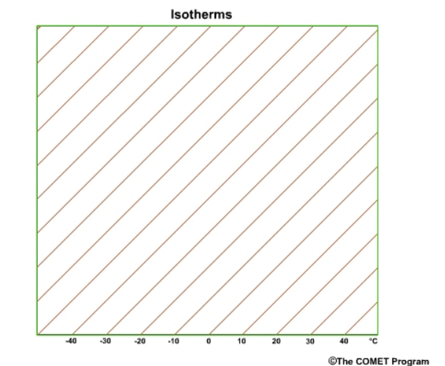
-Isotherms are lines that show temperatures, think of root words, Iso (isolated) Therms (thermals or temperatures).
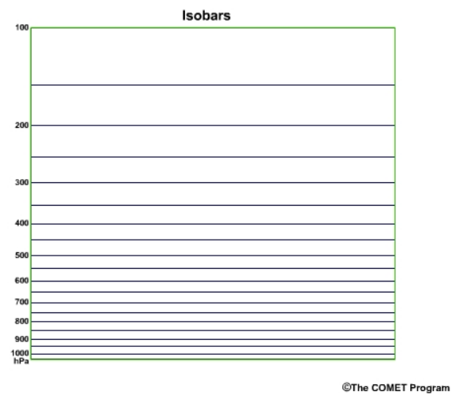
-Isobars are for barometric pressure measured in Hectopascals, same root word concept. Iso (Isolated) Bars (Barometric pressure).

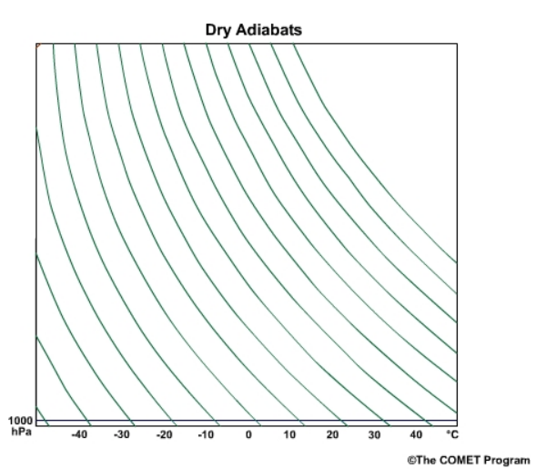
-Adiabats are parcels of air that follow a line assuming that nothing about them has changed. The exact definition of “Adiabatic” is as follows: “relating to or denoting a process or condition in which heat does not enter or leave the system concerned.” For dry parcels of air this is known as a dry adiabat. Which means, if the parcel of air contains no moisture, then the parcel should follow the dry adiabat line all the way up through the atmosphere. This would of course be in only ideal conditions since most things change as they move.
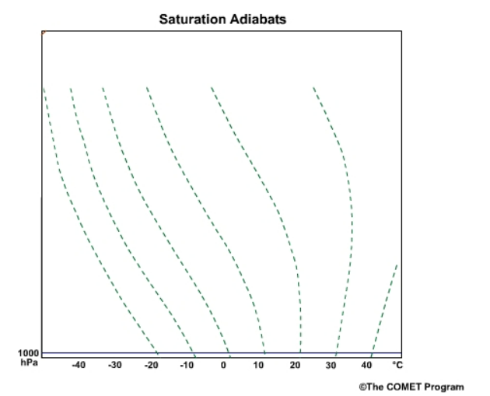
-Saturation Adiabats have the same concept as above, but this time the parcel of air is saturated. Both start at their respective temperature at ground level pressure of 1000 hPa.
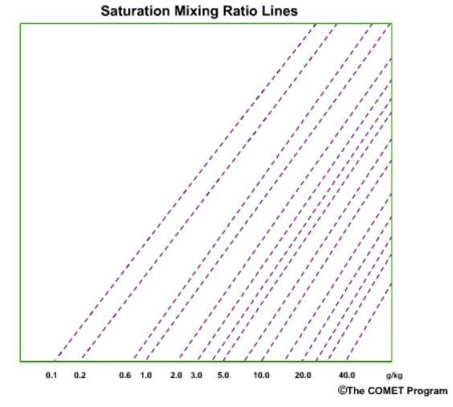
-Saturation Mixing Lines show how much water is contained in a parcel of air in units of grams of water vapor per kilogram of air. The higher the grams per kilogram, the more water and more likely there is to be condensation.
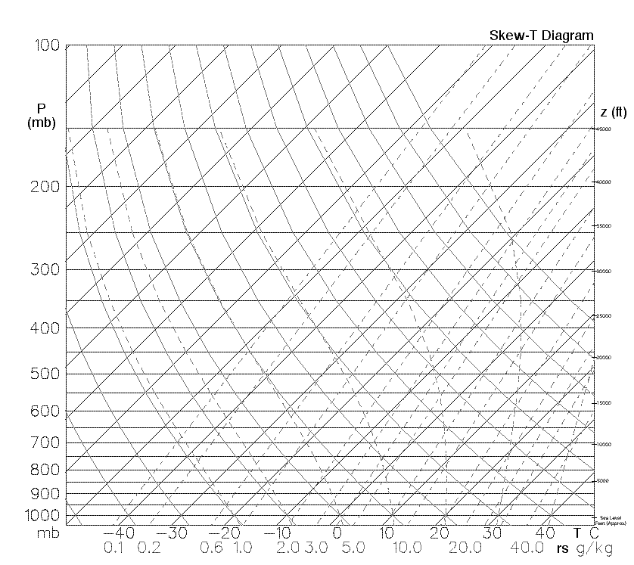
- Full Skew-T Diagram

Other Relevant Information:

-Tropopause is identified by an increase in temperature and a change in wind speed. The exit from the troposphere into the stratosphere is what causes these changes. The wind speed should lower when entering the stratosphere.

-Relative humidity is a measurement of the saturation mixing rate of the Dewpoint temperature and the Regular Temperature in an equation of 100 * (Dew Point Mixing Ratio/ Regular Mixing Ratio). This tells us how close we are to forming clouds. Relative Humidity will tell how much water vapor is in the air before it begins to condense. At 100%, any more water added to the air starts to form clouds, anything below 100 just tells us how close we are to getting to cloud forming conditions.

-Dew Point depression is the measurement of the difference between regular temperature and dewpoint temperature, the lower the dew point depression, the more likely the air is moist. Temps separated by higher than 30 degrees Celsius indicate dry conditions.

-Potential temperature is the temperature of a parcel of air if it follows a dry adiabat down to 1000 hPa. (This is usually expressed in Kelvin but is unnecessary and a conversion could be used.) Think of this as a potential for the temperature on ground level. If that air parcel were to descend to us, that’s what our temperature locally would become.

-Lifting Condensation Level (LCL) is the pressure where a parcel of air becomes saturated if lifted Dry adiabatically. The procedure for this is to find the intersection of the Dewpoint temperature along the mixing ratio lines and the Actual temperature along dry adiabat lines.

-Equivalent temperature is the temperature that a parcel of air would have if all the saturation was removed. To find this, locate the LCL first, follow a saturated adiabat line until it is parallel with a dry adiabat. Follow this dry adiabat down to the original hPa value. The isotherm at this point is the equivalent temperature.

-Equivalent Potential Temperature is the same procedure as above but follows the dry adiabat down to 1000 hPa. This temp is commonly expressed in Kelvin but can be converted to Celsius.

-Wet bulb temperature is the temperature of the air if the parcel of air becomes saturated. Follow the same procedure to find the LCL, then follow the saturated adiabat line down to the starting pressure to find the temperature. This can be very important in surface values. Wet bulb temperatures are being used currently to measure survivable conditions for humans as the climate changes.

-Wet bulb potential temperature is the same procedure as above but brought down along a saturated adiabat line to 1000 hPa, also measured in Kelvin but can be converted.

-Convective Condensation Level (CCL) is the level that air will rise to when heated from below sufficiently to make it saturated. To find this, trace the surface dew point along the mixing ratio line to where the regular temperature intersects with the mixing ratio line. The pressure at this point is the CCL.

-Convective Temperature is the temperature that must be reached to form convective clouds from solar radiation of the surface. To find this, find the CCL, follow the dry adiabat to the starting hPa, then follow the isotherm down to the temperature. This is the Convective Temperature. This temperature is what needs to be reached for thunderstorms to happen. At the time of this writing, this is particularly common in Montana in the summer and in the afternoon.

-Freezing level is the lowest point where the 0-degree isotherm crosses the regular temperature. If the surface temp is below 0, then the surface is the freezing level.

-Wet bulb zero level is the level at which the wet bulb temperature profile intersects the 0-degree isotherm. Measured in hPa. During cool season, the higher this level is, the less likely the precipitation will freeze when reaching the surface. During a convective season, the lower this level is, the more likely you will see a hail event.

Clouds & Cloud Layers: Look for areas where the temperature and dew point come within <5$°$C or less of each other. Depending on the pressure that the convergence appears, it can indicate what type of condensation you should see.
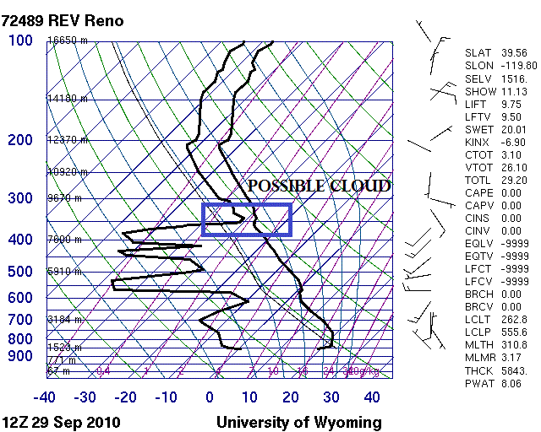
Moisture Caps: A moisture cap is a layer of stable air that prevents convection from starting. On a skew-t it will look like an extreme drop in dew point without a drastic temperature change.
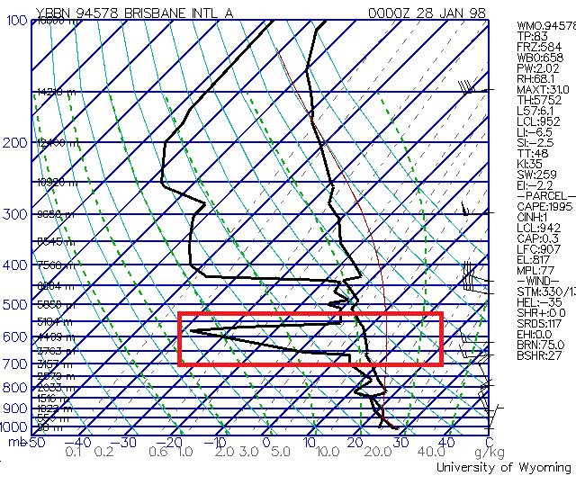

Inversions: An inversion occurs when the air at one altitude is warmer than that of the one below; which is inconsistent with the lapse rate.
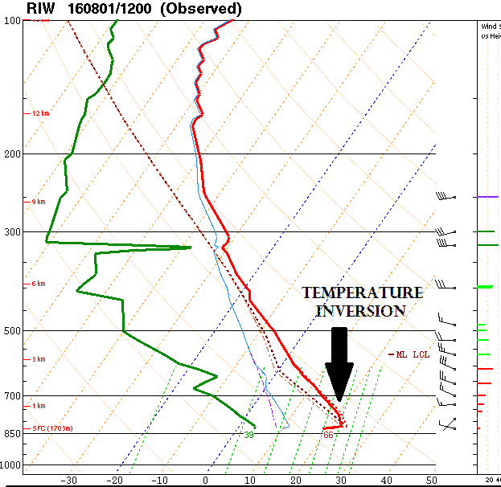

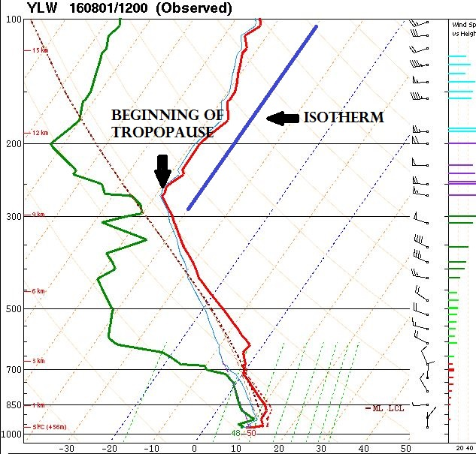
Tropopause: The tropopause can be identified as the beginning of where the temperature begins to approximately follow an isotherm at very low pressures. This is an indication of the start of the stratosphere.

-Lifting Condensation Level (LCL): This is the pressure level where an air parcel becomes saturated. It gives us the lowest cloud level. This can be used to check the accuracy of your measurements. Are you seeing the correct type of cloud that the pressure level of the LCL indicates?
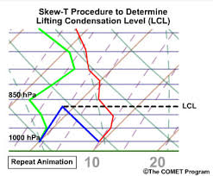
Icing and Instrument Limitations: When moving through cloud layers it is possible for the sensors to become iced over. This is easy to see on a skew-t because the temperature and relative humidity will become one line on the skew-t, after a huge drop in temperature & dew point over a small pressure change.

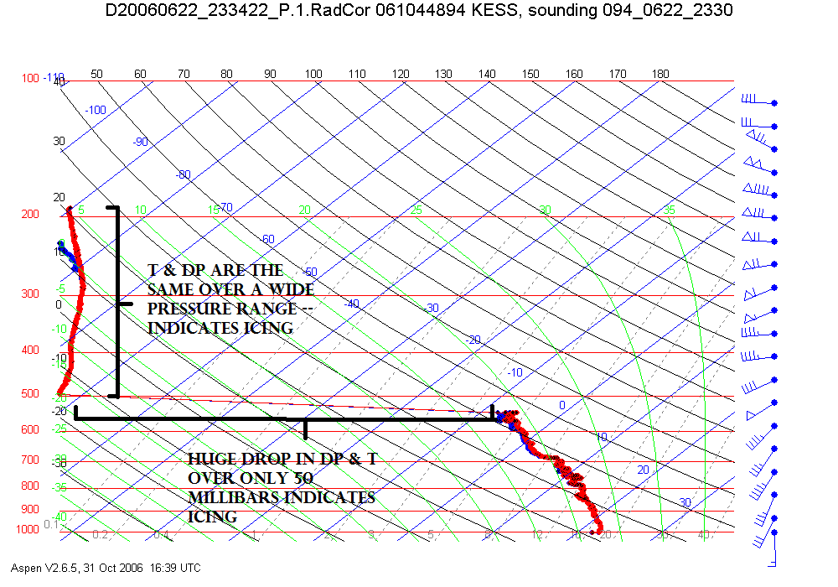

Attachment 9 – NOAA Launch Specifications

Before leaving:
- Inform ATCT in accordance with agency procedure before release time
  - If no ATCT, attempt to notify local Flight Service Station or airport’s UNICOM
- File a NOTAM if necessary (see FAR 101)
- Make sure batteries are charged
- Inspect radiosonde
- Should check RDF equipment every day; range within 20m, azimuth within 0.5 degrees
- Within 12 hours of sounding, do a frequency check (403 +/- 1 MHZ)
- Determine the amount of helium to get an ascent rate of 300m/min (984ft/m)
[Optimum performance: highest possible burst altitude with average ascension rate favorable for obtaining winds aloft data and providing ventilation for sensors; Use previous performances; May change with weather]
Payload weight __________ Balloon size_____________ Optimal helium______________

Site observations:
- Do not launch in thunderstorms; be aware of wind and weather conditions
- Minimize probability of data loss due to obstructions
  - Heights of obstructions should be less than tracking antenna if possible
  - Ensure maneuvering room (at least 18m (59ft) from closest possible obstruction)
- Survey site before launch to determine fixed compass points and landmarks; orient tracking antenna towards a fixed known point and resurvey if moved
- Chart and post all wires, antennas, equipment, buildings, weather, terrain, and other obstructions within a radius of ¼ mile (for safety)
[Separate page]
- Measure azimuth and elevation angles with antenna
  - (Should) make a limiting angles plot
[Separate page]
Make a correction table for pressure readings if release location and the location at which the surface pressure is determined are not collocated
[Separate page]
- Orient equipment in relation to true north (check every 3 months and correct for magnetic variation if using compasses to determine direction)
- Calibrate sensors preflight: compare radiosonde measurements with those taken by agency-approved instrumentation:
  - Acclimate radiosonde to ambient air before making comparison if outside
  - Place sensors as close as possible to each other, suspended or placed on non-conductive surface away from metallic or solid surfaces
  - If comparison values are outside +/- 1°C for temperature or +/- 10% for RH, allow radiosonde to acclimate for another 5 minutes before rechecking; if it fails again, use another sensor
- Check expendables to ensure continuous observations
- Pay attention to exposure and warm-up times for equipment
- Make surface observation as close as possible to release time (procedures provided by individual agencies)
  - Station pressure (to nearest 1/10 hPa; corrected for release point)
______________
  - Air temperature (to nearest 1/10 °C)
______________
  - RH (recorded so that dew-point temperature is to nearest 1/10 °C)
______________
  - Wind speed and direction appropriate to release point (to nearest whole nautical mile per hour [knot] and 5 degrees)
______________
  - Clouds and weather must be observed and reported as “41414 NhCLhCMCH” group NOT USED______________________________________________________________

Launching:
- Use a brightly colored parachute
- Minimize strain on balloon neck
- Train between balloon and payload should be 26m (85ft) or 21-36m (70-120ft)
- Follow radiosonde manufacturer’s instructions
- Frequency must be 403 +/- MHZ (max range 400.15-406)
Frequency ___________________
- Determine and record release time for radiosonde, assign an elapsed time to in-flight data
  - Release window is within 30 minutes of assigned observation time
  - In the event of a delayed release, check battery charge
Release time (UTC to nearest minute) ____________ Elapsed time ____________
- Termination usually occurs with burst
  - May also be terminated with missing data; see below for more
- A second release is required if radiosonde terminates at pressure greater than 400 hPa, as promptly as possible unless pressure less than 400 hPa cannot be attained
  - In the event of a second launch, use a different frequency with the second radiosonde to avoid interference
Second frequency ___________________
  - No more than 3 releases
Recording data:
- Graph data during flight to view any problems that may occur
- Record time-stamped data in a file of elapsed time in seconds, pressure in hPa, temperature in Celsius or Kelvin degrees, and RH in percent of saturation in respect to water; wind velocity data to be recorded as vector wind components or wind direction and speed
- Analyze data to detect system noise or signal dropouts before making calculations
- Minimum of three files of data: time-tagged original unedited pressure, temperature, and RH values; time-tagged balloon position; edited, quality-controlled file of all variables and derived data

Occasions for pre-burst flight termination:
- Pressure anomalies (most important because other values depend on pressure):
  - Check discrepancies between surface pressure and first readings; if for sure outside of agency’s guidelines, terminate flight
  - Missing more than 10 min of contiguous pressure information, terminate
  - If pressure remains constant for more than 5 minutes while in flight, terminate at beginning of interval
  - Rapidly changing or biased pressure data may indicate a leak in the sensor: terminate flight at last known valid data point
- Balloon anomalies:
  - Balloon burst: when pressure changes from decreasing to increasing for at least 2 minutes at pressures less than 400 hPa and 5 minutes at pressures greater than or equal to 400 hPa
  - If ascent rate falls below 100m/min, leading to constant values for at least 5 minutes, terminate
  - If ascension rate changes because of meteorological events, do not terminate
- Temperature anomalies (results in RH also):
  - If doubtful data for more than 3 minutes at pressures greater than 700 hPa, terminate and relaunch
  - Constant (changing less than 0.5 degrees C) for 5 min from surface to 400 hPa, delete and terminate; from 400 hPa to termination, constant temperatures for 10 min necessitate termination
  - Erratic temperatures beyond capabilities of sensor shall be deleted
  - Observer should have knowledge of trends and deviances
- Superadiabatic lapse rates (9.77 degrees C/km)
  - Delete if potential temperature decreases by more than 1.0 degree K over any stratum or interval; examine data to determine if they are erroneous
- RH:
  - Doubtful if temperature is doubtful
  - Observe weather and bias patterns
- Wind anomalies:
  - Erratic angles or spikes be smoothed
  - Multipath propagation: plots waves or steps; if determined, delete
  - Limiting angle is elevation or azimuth angle of RDF antenna above or along horizon, generally no less than 6 degrees from horizon or obstructions; data shall not be used if angles are less than limiting angles
  - Check; flight shall generally continue regardless of wind data; erroneous data shall be deleted

Reference:
Federal Meteorological Handbook No. 3: Rawinsonde and Pibal Observations. Washington, D.C., 1997. Office of the Federal Coordinator for Meteorological Services and Supporting Research. U.S. Department of Commerce and National Oceanic and Atmospheric Administration

Attachment 10 – Initialization Checklist Initialization Checklist Start check 30 minutes prior to launch - Check batteries and change/charge if below 50% - GSU/Computer - Ground Station turned on and connected before starting GRAW program - Connect sonde for initialization - Open the GRAW program - Go to Settings (top left corner of screen – notebook icon) - Program Settings > Communications Tab - Detect both COM Ports and Receiver - Exit out of settings - Click Sounding/Simulation (do not use the wizard – it is good to troubleshoot with this if the sonde will not initialize) - Click Initialize radiosonde - Set sonde and ground station to proper frequency - Enter ground values recorded on data form by Lufft position - Double check frequency and ground values are correct - Click start sounding - Enter lat/long and altitude (longitude is negative in U.S.) Only do this once. - Confirm raw data is coming in - Turn sonde to on position - Unplug radiosonde from computer and place in outer sleeve (make sure antenna and sensor boom are not pinched) - Double check raw data is still coming in - Run balloon fill prediction with current ground values (balloon = 600g; payload = 174g) - Help with fill while sonde acclimates - Get sonde to attach to balloon. - Launch balloon - Confirm software detected launch (if it doesn’t within 30 seconds launch manually) - Wipe down area with sanitizer Latitude_____________ Longitude_____________ Altitude_____________ Attachment 11 – Lufft Setup Checklist Lufft Setup Checklist Begin one hour before launch - Find a level spot for the Lufft tripod 10 m away from any obstructions - Make a note of which direction is north, and the location of the north arrow on top of the Lufft sensor head - Mount the sensor boom into the tripod, making sure to maintain level and stable placement - Double check that the sensor head is pointing north before tightening down all the tripod bolts - Feed the solar panel cable and the Micro-USB through the holes in the bottom of the housing case - Secure the solar panel leads in the charging terminals of the data logger - Plug the Micro-USB into the USB port of the data logger - Connect the power cables from the data logger to the 12 V battery - Plug the USB cable into a tablet or other device with the PC400 software - On the device, start PC400 and click “Connect” in the top left corner - Click the “Monitor Data” tab and confirm that data is being reported - Allow the station to record ambient conditions until launch is terminated Attachment 12 – Lufft Operation Checklist Lufft Checklist Start check 30 minutes prior to launch - Fill out data form - Attach parachute and dereeler to sonde after initialization - Check dereeler for any snag (allow a foot or so of line out of the dereeler) - Hang sonde to acclimate - Record balloon fill prediction amount and helium tank value - Help with fill while sonde acclimates - Launch balloon - Record helium tank value - Sanitize Lufft station - Call the local ATC 10 minutes before launch to provide launch location, launch time, and estimated maximum altitude (100,000 ft) Attachment 13 – Primary Balloon Fill Checklist Primary Fill Checklist Begin fill 10 minutes prior to flight - Set out 5” piece of duct tape - Check regulator attachment to helium tank - Wait for OK to fill from person initializing - Note beginning psi level of helium tank - Have initializer yell out fill value - If tank will need to be changed during fill have 2nd tank next to 1st - Get gloves - Get balloon from box - Attach balloon neck to helium hose nozzle by rotating the neck until about a hand’s width on nozzle. - Open regulator slowly. - Tape balloon neck to nozzle - Secure balloon to tripod with zip tie and string - Fill balloon (clockwise is open) - Tap pressure gauge occasionally to get accurate level - Look and listen for balloon leaks. - Carefully pull tape and pull balloon off nozzle (don’t let go of balloon!) - Allow secondary fill to attach sonde with zip tie - Fold neck of balloon over and hold neck for duct tape - Yell for verification of data from initializer - Walk out from obstructions to release balloon. - Count down and launch - Organize fill area and prep for next launch (remove empty tanks, throw away any garbage, replace tools to proper locations) - Wipe down regulator with sanitizer Attachment 14 – Secondary Balloon Fill Checklist Secondary Fill Checklist Begin fill 10 minutes prior to flight - Set out zip ties and 2x 1.5’ pieces of duct tape - Have wire clippers in pocket - Get gloves - Wait for OK to fill from person initializing - Unroll balloon - If tank is changed mid-fill – Use all of 1st tank and note amount needed from 2nd tank then move regulator to 2nd tank - Yell for radiosonde (primary initializer brings to fill) - Attach zip-tie and radiosonde loop tightly to neck of balloon - Clip extra end of zip-tie - Cover zip-tie with one piece of duct tape - Duct tape thoroughly over folded balloon neck - Double check dereeler is not tangled - Make sure no strings from sonde are tangled - Cut tripod safety line - Count down and launch - Organize fill area and prep for next launch (remove empty tanks, throw away any garbage, replace tools to proper locations) Attachment 15 – File Saving Naming Conventions File Saving Naming Conventions - Profile Data: Save Profile data table (Reports > Save as .txt) using the naming convention: - LocationAcronymFlightNumber_hhmmUTC_ddmmyy_Computer_profile - Example: Profile data from flight #5 launched from San Antonio (example of established acronym= SA) at 17:06 UTC on October 14th 2023 with computer named “Montana1” would be saved EXACTLY as follows: - SA5_1706UTC_101423_Montana1_profile - Raw Data Table: Save BOTH sides of the raw data table. Pop-up windows to name and locate saved raw data files (1 and 2) appear individually. (Save active view as .txt) - LocationAcronymFlightNumber_hhmmUTC_ddmmyy_Computer_raw1 - LocationAcronymFlightNumber_hhmmUTC_ddmmyy_Computer_raw2 - Example: Raw data (files 1 and 2) from flight #12 launched from Buffalo (example of established acronym= B) at 10:12 UTC on April 8th 2024 with computer named “NY1” would be saved EXACTLY as follows: - B12_1012UTC_040824_NY1_raw1 - B12_1012UTC_040824_NY1_raw2 - Skew-T Diagram: Save Skew-T (Save active view as .JPG) - LocationAcronymFlightNumber_hhmmUTC_ddmmyy_Computer_skewt - Example: Skew-T from flight #30 launched from Lakeview (example of established acronym= LVW) at 00:00 UTC on August 1st 2022 with computer named “Intel1” would be saved EXACTLY as follows: - LVW30_0000UTC_080122_Intel1_skewt - Graw Simulation File (GSF): Backup GSF data (Documents>Grawmet5>Archive) – Leave name as default - BUFR Data Files: Backup BUFR data (Documents>Grawmet5>Reports) – only save 502 format files - LocationAcronymFlightNumber_hhmmUTC_ddmmyy_Computer_bufr - Example: BUFR file from flight #2 launched from Conway (example of established acronym= CWA) at 01:59 UTC on June 30th 2023 with computer named “Arkansas_laptop” would be saved EXACTLY as follows: - CWA2_0159UTC_063023_Arkansas_laptop_bufr - Overview Form: - LocationAcronymFlightNumber_hhmmUTC_ddmmyy_Computer_overview - Example: Overview form for flight #10 launched from Roswell (example of established acronym= RNM) at 15:12 UTC on January 2nd 2024 with computer named “GS-1” would be saved EXACTLY as follows: - RNM10_1512UTC_010224_GS-1_overview - Upload each of the above flight data files (1-6) to external hard drive after every flight Upon completion of balloon flights: - Lufft Weather Station Data: Save Lufft data (.dat) to a computer using PC400 software (Collect Data tab) - LocationAcronym_ddmmyy_lufft - Example: Lufft data from Bozeman (example of established acronym= BM) valid from April 8th-10th 2024 would be saved EXACTLY as follows: - BM_041024_lufft - Moving Data to Localized Folder: Move all data to a localized folder. Name the folder using the launch date. - 062922 Name of folder - Example: All data from June 29, 2022.

