Lufft Operation Directions

Screw the white datalogger box onto the PVC pipe using the U-bolts.
Slide the Lufft sensor on top of the white dome on the end of the metal rod.
Slide the metal rod with the Lufft sensor on the end (with the stopper firmly attached) into the PVC pipe.
Make sure the “North” arrow is pointing north (the arrow is on top of the Lufft sensor).
Connect the green-tipped cord to the bottom of the Lufft sensor - it is directional, so investigate the connection before forcing it on.
Hook the solar panel to the Lufft datalogger by putting the leads into the CHG port on the right hand side of the CR300 datalogger.
The wiring is as follows for the data cord:
Yellow wire to port C1
White wire to port G, immediately right of C1.
Brown wire to SW12V.
Red/Black leads from battery to +- BAT ports.
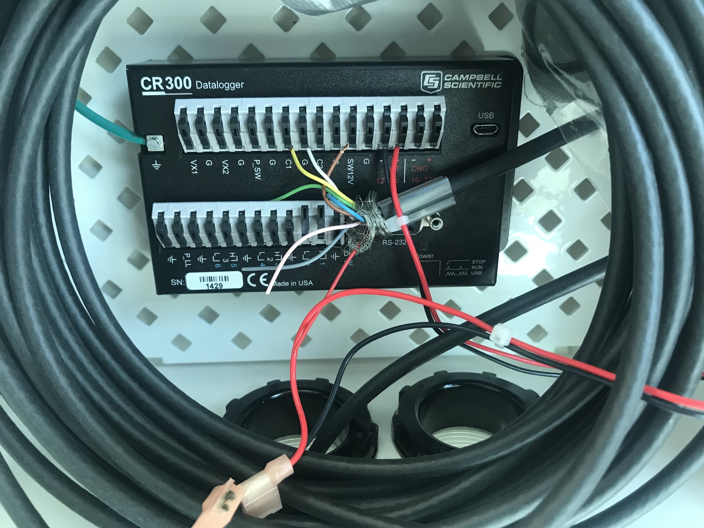

Monitoring Data
To monitor the Lufft data, you need to connect to the CR300 datalogger it via the microusb port. Connect the USB to microusb cable to a computer that has the PC400 datalogger software installed.

PC400 software should be installed on all comuters/tablets.

Once a computer is connected to the datalogger, open PC400 on the computer from the Desktop.
Hit the “connect” button in the top left of PC400.
If the datalogger doesn’t connect to PC400, check the connections of the battery and microusb.
Once you are connected, go to the “Monitor data” tab to see the current values.

Collecting Data
Go to the collect data tab. There are two buttons: “overwrite” and “append to file”.
Select the data tables you want to save (ten second collect frequency, two second collect frequency).
To change the save directory, hit “Change table’s output file”. It should be in CampbellSci, don’t change this.
Select “append to file”.
Hit “Start data collection”. Data should download to your device.
*Always double check time zone is accurate for your field location!

Clearing tables (don’t do this unless you want to remove all data from the device!).

Select the red check box on the top menu bar. A window should pop up.
Hit the second tab. Select the tables you want to clear and press “Reset tables”.

